ANTIGONISH FOOD SECURITY COALITION

A COMMUNITY FOOD ASSESSMENT
FOR NORTHEASTERN NOVA SCOTIA

2013



Funded by the J.W. McConnell Foundation: Sustainable Food Systems

TABLE OF CONTENTS

Executive Summary- Page 3

- Background and Methods- Page 4

2.0 Profile of Northeastern Nova Scotia- Page 9
2.1 Community Profiles Page 9
2.2 General Trends Page 12
2.3 Community Health Data Page 12
2.4 Alternative Food Programs Page 13 to 16

3.0 Environmental Scan Page 17
(Agricultural Profile and Food Supply Chain)
3.1 Farmers, Food Processors, Fishermen Page17
3.2 NS Vegetable and Fruit Self-Reliance Page 19
3.3 Livestock Self-Reliance Page 19
3.4 Supply Managed Industries Page 20
3.5 Food Buyers Page 21

4.0 Survey Findings Page 25
4.1 Food Producer Profile Page 25
4.2 Farmer Profile Page 26
4.3 Market Assessment Page 28
4.4 Market Expansion Page 31

5.0 Food Buyer Survey Results Page 37
5.1 Demographics of buyers Page 37
5.2 Individual Consumers Page 41
5.3 Wholesale Buyers Page 48
5.4 What do buyers think can be done? Page 55

6.0 Challenges and Opportunities Page 56

7.0 Recommendations Page 58

Bibliography and Appendix Pages 60 to 84

Executive Summary

One of the goals of the Antigonish Food Security Coalition has always been to create a local food hub (a physical distribution centre for local food) to increase access to local food in Northeastern Nova Scotia. In November 2011 the J.W. McConnell Foundation sought proposals related to sustainable food systems. As part of this application process the coalition felt an assessment of the local food system was needed in order to investigate whether our vision for a local food hub could become a reality or whether another solution was suitable. The coalition identified a number of questions related to the local food system: What data currently existed about our community (community profile)? What was the agricultural profile for the region? How much local food is produced? What was the demand for local food? What are the challenges that exist between producers and buyers? Would farmers expand to support a food hub? Would the community support an initiative such as a food hub? In the spring and fall of 2012 the coalition reviewed existing agricultural and community health data, conducted a consumer demand survey with 103 individual consumers, conducted face to face surveys with 27 food producers (including farmers, processors, fishermen) and 24 wholesale food buyers (i.e. restaurants, institutions, grocers).

Results identified a number of challenges and opportunities to increase local food in Northeastern Nova Scotia. Some of the challenges included inadequate supply of local food to meet needs of large institutions and businesses, varying food safety requirements/liability insurance needs by wholesale buyers, more labour needed by local producers, lack of a local food store in downtown Antigonish and many others. Opportunities included the large amount of potential agricultural land in the area, a strong demand for local food and potential to work with many partners who are interested in this issue in Nova Scotia. Upon reviewing the data and conducted a community discussion in February of 2013 the coalition developed a list of five recommendations. These recommendations include: exploring the possibility of a local food store in downtown Antigonish that may develop into a local food hub (through linking into local food distribution across Nova Scotia), continuing education about local food in the community, supporting the garden apprenticeship program at Bethany motherhouse, collaborating with provincial and national partners to advocate around issues impacting small producers and continuing to work with the Antigonish Poverty Reduction Coalition to address the food needs of people living on low incomes.

- Background Information and Assessment Methods

About the Antigonish Food Security Coalition

The Antigonish Food Security Coalition formed in 2009 out of work from VOICES Antigonish, a community organization, who had undertaken community initiatives such as community gardening and a local food box program. VOICES Antigonish saw the need for further advocacy and networking related to sustainable food and approached other community partners to form the coalition.
The Antigonish Food Security Coalition is made up of a network of active individuals, groups and community organizations working to engage and communicate with community members and organizations interested in the issue of food security in the town and county of Antigonish. The coalition uses the Dietitians of Canada Community food security (CFS) definition which states that CFS “exists when all community residents obtain a safe, personally acceptable, nutritious diet through a sustainable local food system that maximizes healthy choices, community self-reliance, and equal access for everyone (Adapted from Dietitians of Canada, 2007).
Membership for the Board of the Coalition is drawn from regional and community organizations, including VOICES Antigonish, The Kids First Family Resource Center, the Antigonish Women’s Resource Center, the Antigonish Poverty Reduction Coalition and the Antigonish Farmers Market; one member is also drawn from each of the following, the Antigonish Regional Development Authority, the Nova Scotia Department of Agriculture, the Guysborough Antigonish Strait Health Authority, as well as one member to represent both the town and county councils of Antigonish. There have been members from the following organizations in the past; St.F.X. student food bank, local community food bank and the student union at St.F.X. Due to high rate of turnover in these organizations it has been difficult to maintain consistent membership.
Since 2009 the coalition has been involved in a number of initiatives to build community food security. These projects have included advocacy related to the Nova Scotia Food Costing Data and Income support programs, creating community discussion and action related to the issue of food security, offering community education programs on food preparation/canning/freezing, supporting the community gardening projects of VOICES and hosting such events as the Incredible Community Picnic.

The coalition has the following goals:

Goals
1. Participate in the development, implementation and evaluation of programs and projects to build community food security.

2. Collaborate with organizations that have existing programs to provide support and work together as appropriate.

3. Identify specific populations where programs/projects are needed and would be feasible.

4. Through coalition members, stay up to date on provincial, national and international food security initiatives, and determine their feasibility in a local context.*

5. Increase awareness, engagement and commitment to build food security in the local area.

* One Coalition member is a member of the Nova Scotia Food Security Network. Two members are also members of Activating Change Together (ACT) for Community Food Security (CFS) part of the Community University Research Alliance (CURA) out of our local university, St.FX in partnership Mount Saint Vincent University (MSVU) in Halifax, NS. For more information on CURA’s ACT of CFS please visit http://www.foodsecurityresearchcentre.ca/ actforcfs

Sustainable Antigonish Roundtable

The Antigonish Food Security Coalition is a partner within Sustainable Antigonish, a community based, non-profit organization dedicated to promoting, supporting, and advancing sustainable development in the Antigonish area. Sustainable Antigonish helps to support the county’s integrated community sustainability plan, developed in 2010, to create a more resilient, vibrant and healthy community.
Sustainable Antigonish holds roundtable meetings with representatives from the community action teams, associates and community members at large. With collaborations and open discussions between the community groups involved, the momentum and support for sustainable development has been growing significantly. Sustainable Antigonish has proven to be an excellent jump off point for organizations to garner community support and build mutually beneficial relationships.

1.1 Defining the Geographic Region of Assessment

The original goal of this assessment was to look at the geographic region of Antigonish town and county. However, it quickly became obvious that due to the rural nature of the region many people travel between communities to access goods and services and many food producers travel to a variety of farmers markets beyond the one location in Antigonish. It is also clear that many rural communities are facing challenges similar to Antigonish. It became apparent that it may be advantageous to partner with other regions in the future or create regional projects to address similar challenges. This assessment was focused on Antigonish but broadened to look at Northeastern Nova Scotia. For the purposes of this assessment we are defining the region as Antigonish town and county, Guysborough town and county (the part of Guysborough county within the local health authority), Port Hawkesbury (in Inverness County) and the eastern part of Pictou County (the geography closest to the Antigonish County boundary). The assessment was Antigonish centric however, as some parts of the region have their own food security working groups who are doing similar work/research. We see these groups as potential partners in the future. This assessment solicited opinions and experience about local food from across the region but did not attempt to assess the entire food system of Pictou since it is a relatively large population and they are already spearheading some food security initiatives forward in their area. The coalition did speak with several producers from Pictou County since they often attend our Farmers Market in Antigonish and sell locally in our county. A similar process was followed for Guysborough and Port Hawkesbury- we sought opinions from key informants in these areas.

1.2 Community Food Assessment: Project Goal, Key Questions and Methods

Our Goal: To create a food hub (a physical local food distribution centre) to address local food availability and accessibility by supporting an increase in production, and the marketing and distribution of fresh food through community based food micro-enterprise initiatives (mobile farmer’s market, community and school gardens, distribution of local food in public and private institutions, etc.).

In November 2011 when the application to the J.W. McConnell foundation was submitted our vision was to create a food hub and this goal was still present as we started the community assessment. It should be noted that our vision of what the food hub may include was unclear.

However, we had several questions that needed to be answered through the assessment:

- What data currently exists that relates to food in our region? What is our regions’ unique community profile? Reviewed/Search Community Counts Data from the Nova Scotia Department of Finance, Reviewed Local Health Survey Data, Reviewed Provincial Food Costing Data, Reviewed community support programs that address food issues

- What is the agricultural profile of our region and how much food is produced? Would we have adequate supply to support our vision? Obtained as much information as possible from the Nova Scotia Department of Agriculture and information obtained from key informant interviews/surveys

- What was the demand for local food? How could a local food hub meet the demand? What are the challenges that exist between producers and buyers? What opportunities are there? Surveys of producers and buyers, Small consumer demand survey in the community

- What did local farmers think? Would they be willing to scale up to the meet the demand? What would they need to do this? Producer Surveys

- Would the community support an initiative such as a local food hub? What model would work here? Community Discussion

- What should our next steps be? Community Discussion

Each of the six areas of questioning was reviewed and a variety of possible methods discussed. In the end, the methods outlined above for each were chosen. The information for both question area one and two was the easiest to obtain as existing community data was used. Although we could not find all the information we wanted it provided us with a baseline of information and ensured we didn’t spend time finding information that already existed.

For question areas three and flour we decided that it was important to conduct one on one surveys so that we could connect with producers and buyers and let them know about our project. This allowed the researcher to answer the questions contained in the survey but also to make notes related to other challenges/opportunities the producer/buyer revealed to us. This additional information (beyond the survey questions) is noted throughout the report where appropriate. We also felt that would be the most valuable way to obtain the information needed (i.e. we felt that producers/buyers would be more likely to respond to a request for a one on one discussion vs. getting a survey in the mail). We developed a set of community wide buyers/demand surveys that were used in these interviews. See the surveys used in appendix 1. Each of these surveys was pretested for ease of use on volunteers. Members of the coalition also reviewed the questions and made many revisions.
The surveys were conducted between the spring and fall of 2012. The project’s researcher used selective sampling to contact farmers, food buyers (i.e. institutions etc.) and set up one on one interviews. The researcher also approached local food vendors at the Farmers Market to set up interview times for later, sent information out to farmers through the Department of Agriculture and used the knowledge of the coalition members about existing farmers in the local area. The researcher also attended a training workshop being put on by the Department of Agriculture for local producers to connect with as many as possible. Purposeful sampling was also used as some of the contacts we selected suggested other contacts that should be included in the data collection. Each interview/survey consisted of introductions including to the food security coalition and the project we were undertaking. Each participant was ensured confidentiality. The researcher then went through the survey tools with the interviewee. As noted earlier there were some cases where these questions lead to deeper discussions and the interviewer tried to capture any observations/themes while the interviewee was talking. Those themes are included in the agricultural profile section of this report and with the survey results where appropriate. The results from the actual survey questions are included in the survey results section.
One of our major limitations to the interviews was that we were unable to talk to all the individuals we would have liked. Some individuals were difficult to contact and in those cases written surveys were mailed to them. Some of these surveys were returned but were incomplete. While tallying up the surveys, certain incomplete questions were recorded as not applicable so not to interfere with our results. The time of year was also a challenge for this part of the assessment as producers are very busy in the spring and fall.
The individual consumer surveys were administered on a self-completion basis and also digitally. Hard copies of the survey were left at prominent locations throughout the community and the digital edition was promoted by social media, local newspapers, and tear-off booklets that were left in strategic locations throughout our region. We felt it was important to obtain information from individual consumers. However, we also knew that to do a comprehensive survey and capture a cross section of the community in Northeastern Nova Scotia would use most of our time and resources. We felt that we the best way to capture the community’s input would be through community discussion. The individual surveys still provided us with insight that we used for discussion in the community discussion.
As the data was being gathered in the spring and fall of 2012 the Food Security Coalition was meeting on a regular basis to review the data and discuss a plan for future action. In January of 2013 it was decided that it was time to gather more community input to inform the community of the project in a larger forum and get their feedback on what the next steps could be. An initial meeting was schedule for February 9th but had to be cancelled due to a storm in the area. The meeting was rescheduled for February 16th and we had 40 people come to the meeting despite other major events taking place at the same time (i.e. a local family fun day). The day was framed at the VOICES annual stir-fry. This day is hosted annual each year by VOICES but this year we decided to frame it around our next possible steps related to this work and a possible food hub. The agenda of the day consisted of 1) Introduction to the coalition and our project (purpose and results) 2) Guest speaker from the Nova Scotia Food Policy council 3) Facilitated discussion/reaction. Please see the notes from the session in the appendix. From this initial meeting four more community discussion meetings were held between April and July of 2013 and those discussions continue to grow and continue. Those discussions helped to inform the recommendation section of this report.

2.0 Profile of Northeastern Nova Scotia

2.1 Community Profiles of the Assessment Area

Antigonish Town and County

The population of the town and county of Antigonish is approximately 19, 574 (Stats Can, 2011). The Town of Antigonish is a cultural capital of Northeastern Nova Scotia, otherwise known as the “Highland Heart of Nova Scotia”, dating back to 1889. The town is internationally known for the Antigonish Movement and the Coady International Institute, both based around community development and social justice. 2011 Statistics Canada data revealed that the most common industries in Antigonish are Educational Services (15.5%), Retail (15.5%), Health Care and Social Assistance (13.5%), Construction (9.3%), Agriculture, Forestry and Fishing/hunting (8.1%) and lastly Accommodation and Food Services (6.4%). Ethnicity is similar to many rural towns in Nova Scotia as 55.2% of the people consider themselves to be Canadian, 30.8% of Scottish descent, 20.3% Irish, 15.1% French and 1.8% African/Black origin.
Antigonish is full-service town with a major regional hospital, home of St. Francis Xavier University (St.FX), an enterprise base and a bourgeoning network of ecologically and socially conscious citizens Antigonish has been, and continues to be a unique and vibrant place to live with a great sense of community. Many people within the larger region (from Port Hawkesbury and/or Guysborough) travel to Antigonish for medical services, shopping or entertainment. Over the past decade, Antigonish has been making great effort to set itself apart as a pilot community for sustainable development in our region. The town is currently evaluating various sustainable community initiatives from the Transition Movement to the Cittaslow movement.
Antigonish has a weekly Farmers Market that runs from May until October located at the Exhibition Grounds in the centre of Antigonish. The market has been up and running since 1995. The town has two grocery stores both located outside the core of the town- Sobeys and Superstore. Previously, the town had a busy Co-op store in the downtown core of Antigonish. Co-op Atlantic moved the store outside of the downtown and this negatively impacted its business (along with other factors- explained later in the report). An IGA was also in a downtown location in Antigonish but also closed. Antigonish has a Local Food Box program coordinated by VOICES Antigonish. There are some small restaurants which support local food producers. Bennett’s Market, also located outside the downtown core is also a good source for local food in the area. They have a bakery, ice cream and produce. The local school has a cafeteria and the food service is catered through contract with the local school board through Chartwells. Food Service at the university is provided by Sodexho.
The town of Antigonish is surrounded by many vibrant and self-motivated communities within the county of Antigonish. These communities include Clydesdale, Havre Boucher, James River, Lower South River, Mahoneys Beach, Malignant Cove, Paqtnkek First Nation, Pomquet, Afton, Salt Springs, St.Andrews and Tracadie. Many of these communities have great community volunteers who support local events and activities.
One example is the community of St. Andrews. St. Andrews is often used as an international example of a “can do” community. The Coady Institute, an organization interested in how communities organize themselves and the unique features of communities that drive development, decided to do a case study on St. Andrews outlining many of the key attributes that make it so (Cunningham and Fiander, 2009).

Town of Port Hawkesbury

The town of Port Hawkesbury is located approximately 40 minutes (60 km) away from Antigonish. The population of Port Hawkesbury was 3361 people in 2011 with ethnicity similar to that of Antigonish. The town is heavily reliant on the local pulp and paper mill- currently Port Hawkesbury paper. The mill produces high gloss super calendar paper. It went though a shut down for a 12 month period between 2011 and 2012. The community is in need of new industry and business. 2011 Statistics indicates that manufacturing is the backbone of the local economy. 15.5% of the population working in that sector. Other major industries in the town include: Retail (15.5%), 9.5% Health Care and Social Assistance, 8.6% Public Administration, 8.6% Educational Services, and 5.7% of people working in accommodation and food services. Port Hawkesbury has very limited options to purchase local food. There is a local group working on the issue of Food Security called Tables. They supported the implementation of a local community market that was lead by the local regional development authority. The community market currently runs on Thursday evenings every two weeks at the Port Hawkesbury Civic Centre. Sobeys and Superstore both have store locations in the area along with Wal-Mart. There was a successful Co-op for years but Co-op Atlantic changed the location and the type of product offered and this lead to its closure. There are many
people from neighboring Richmond county who travel to Port Hawkesbury and/or Antigonish for services and shopping.

Guysborough County

Guysborough County contains many rural communities spread over a large land mass. The population of Guysborough County is 8164 people (Stats Can, 2011). Communities included in this area are Canso, Cross Road Country Harbour, Guysborough, Larry’s River, Liscomb Game Sanctuary, Melrose, Moser River, Mulgrave and Sherbrooke. The major industry in this area is heavily reliant on forestry, Christmas tree farming and fishing. This fact is supported by 2011 Statistics Canada data which indicates that 18% of people work in the Agriculture, Fishing or Forestry Industry. 6.7% work in manufacturing. There is a plant located in Mulgrave that manufacturers fish oil supplements. 11.2% of people work in health care and social assistance, 10.6% in construction and 9.6% in Retail. Although the ethnicity is similar to the other surrounding areas there is a small Afrikan Nova Scotia community in the county.
The local school Chedabucto Place is very progressive and has an active Green team of young people who are strongly interested in the issue of food. The school has a large school garden. They also recently hosted a Hunger bites symposium for youth. A food network has just begun to form in the area to talk about addressing food issues in the local area. Local food sources are limited. There is a farmers market in Guysborough on the waterfront that runs for a short time in the summer. There are small rural grocery stores in Guysborough and Canso.

Pictou East

For the purposes of this report it was decided to look at the eastern part of Pictou County that is closest to the boundaries of Antigonish. The communities included in this region (as defined by Provincial electoral boundaries) include: Blue Mountain, Hopewell, Little Harbour, Merigomish, Pictou Landing, Pictou Landing First Nation, Thorburn and Trenton. The population of this area in 2011 was 15, 155 (Statistics Canada). These communities represent the rural part of the county. We were unable to obtain the most significant industries in this part of the region due to a lack of data in this regard.

2.2 General trends within Northeastern Nova Scotia

See appendix 2 for the entire demographic profile of Northeastern Nova Scotia. Some trends of note are that both average and median individual and family incomes are lower than Nova Scotia averages. Guysborough County showed the greatest discrepancy. Levels of post-secondary education are also lower in the region compared to Nova Scotia averages. One of the most significant trends noted from the data is that population numbers have been trending downward in the area. This represents a challenge in the area as people have moved west for employment. The area is in need of economic development and projects that will keep more people working in the area. This is also a significant opportunity as agriculture and food could represent an area of potential growth in the area- especially given the rural landscape.

2.3 Other local data of relevance- Community Health

In 2010 the community health boards of the Guysborough Antigonish Strait health authority undertook a community health assessment in each of their communities/regions of the district. They held 40 community conversations across the district with 344 local residents. The focus groups were facilitated by an experienced facilitator and all community conversations were focused around a consistent group of questions. The issue of poor nutrition and unhealthy eating was consistently identified as an issue by community members. This is further supported by the data the community health boards obtained from the 2010 Understanding Our Health Survey which was a telephone survey of 1121 residents in the district and conducted by Market Quest Incorporated, a professional survey company. The data from the survey showed that 6 out of 10 residents did not meet Canada’s Food Guide for consuming the recommended number of vegetable and fruit servings. It also reported a higher rate of obesity in the region compared to the rest of Nova Scotia. 78% of respondents identified poor nutrition and obesity as an issue affecting their health. Within the umbrella of poor nutrition, unhealthy eating habits, lack of awareness of healthy food options, and lack of access to healthy food choices were specified. This data points to a need for interventions that will specifically increase consumer consumption of vegetables and fruits. See Appendix 3 for a complete listing of the data.

Can Nova Scotians Afford to Eat Healthy?

Statistics Canada revealed that 9.3% of households in Nova Scotia have difficulty affording healthy foods (i.e. they have some level of food insecurity). Recent research completed by Food ARC, the Food Action Research Centre in Halifax revealed that 23, 561 people were assisted by food banks in Nova Scotia in March 2012. (3) Their participatory food costing project which surveys the cost of a nutritious food basket across the nine DHAs in Nova Scotia reports that it costs $882.28 to feed a family of four per month. This is up significantly from the time they started collecting the data in 2002 when it cost $558.55. The affordability scenarios revealed in their report show that many families who are working at minimum wage or on social assistance would not be able to afford to eat a healthy diet. The data also showed that it costs more to feed a family in rural communities and more in Northern parts of Nova Scotia (where our region is located). This data points to the importance of the issue of food insecurity within our local context and the need to include strategies to address this issue within our ongoing food security initiatives.

2.4 Alternative Food Sources and Programs

Beyond the standard means of accessing food in our region, from supermarkets, co-ops, independent grocers, small food vendors, and convenience stores, to public and private institutions and, restaurants, there are a domain of alternative food sources and programs. These alternative food sources and programs are often, though not always, established as a buffer or safety net for those having difficulties meeting their daily food intake requirements, particularly of fruit and vegetables. Other sources and programs however, such as the Local Food Box program and food skill building, are not only practical but also educational. They are intended to empower and facilitate community members’ abilities and capacity to make healthy food choices. Community Supported Agricultural (CSA) initiatives are also increasing in popularity as an alternative food source.

Community Supported Agriculture (CSA)

Community Supported Agriculture (CSAs) initiatives, initiatives where members by in at the beginning of the season in exchange for a fresh supply of fresh fruit, vegetables, herbs, eggs, and sometimes meats throughout the growing season, have been increasing their presence in the region over the past few years. In Antigonish County alone there are 4 such initiatives supplying families in and around the general vicinity of production. This model establishes a more profitable or, at least a more viable and scalable model for small-scale producers.

Charitable Food Programs

There are numerous charitable food organizations and programs in our region, ranging from food banks to soup kitchens. It is estimated that there are 5 or more official food banks in the region. These are food banks officially registered with Feed Nova Scotia. There may be more programs that are not listed with Feed Nova Scotia but that information was difficult to obtain as some would be made through informal referrals and are often hidden. As cited earlier in this report, 23, 561 people accessed a food bank in Nova Scotia in March 2012. Feed Nova Scotia states in their recent report when referring to the northeastern Nova Scotia that the “most striking in this region is the change in the source of income. Households reporting current employment income as their primary source changed significantly: 13% in 2010, 3% in 2011 and 9% in 2012. Households citing employment Insurance have steadily decreased: 17% in 2010; 5% in 2011 and 4% in 2012. At the same time, there was an increase in the percentage of households citing Income Assistance as their primary source of income: 32% in 2010, 61% in 2010 and 2012.”
Of those using the food banks in Nova Scotia, 31.5% are under the age of 18.
59.4% are on income assistance, 45.2% of users are single and 22.9% are single parents. Moreover, 64% of those using food banks are rental market tenants and 19.5% are social housing tenants. Little secondary data exists on soup kitchens in the area but there are several free lunches provided by non-profit community organizations in our area.

Community Gardens, School Gardens, & Self-Production

VOICES, a non-profit community organization in Antigonish has been expanding the number of community gardens in and around Antigonish over the past 8 years. VOICES formed in 2004 when the downtown Co-op grocery store closed its doors. In response, citizens had a growing concern about the availability and accessibility of fresh, nutritious and locally produced foods downtown and throughout Antigonish.
Beyond providing fresh, nutritious locally produced food to community residents, VOICES strives to increase awareness around food security through a variety of methods. Participating members learn some basic dos and don’ts of gardening, from land preparation, planting and maintenance to harvesting, preservation and healthy eating. As of 2012, there were 9 community garden locations in Antigonish producing a variety of fruit and vegetables.

School Gardens

School gardens are also gaining momentum in our area. The local Antigonish elementary and Jr. High school have both initiated school garden projects. These gardens are educational pieces where students have the opportunity to get their hands dirty, while learning about the where food comes from and how food is grown through observing its progress over the year.
The Chedabucto Education Center in Guysborough exemplifies a successful school garden model - The Garden Project by the schools youth lead green team. Since 2010, students of all different ages in partnership with the community have been partaking in the annual planting and harvest of fruits and vegetables. Each year there is an annual harvest celebration whereby students get the opportunity to help prepare their produce for a large harvest meal. Surplus vegetables and fruits that are not prepared for the harvest meal are bagged and sent home with students. At the Chedabucto Education Center only 12% of students consumed at six servings of fruits and vegetables per day in 2011 and with the Garden Project they hope to see improvements over the coming years. Ways in which faculty intend to address this statistic is by introducing fruit and vegetables during classroom breaks and by improving the school breakfast program. The school also intends to increase exposure of and to offer free fruits and vegetables at produce stands around the school. The project also plans to utilize its government inspected kitchen facility to educate students on food safety and fresh food preparation.
Other schools within the region have recently started to implement school garden projects within their schools and are at varying stages of implementation- some of these schools are within the Antigonish area and one is in Port Hawkesbury.

Local Food Box Program

The Local Food Box Program is a program offered by VOICES. Similar to the CSA initiative, the Local Food Box Program delivers a box full of fresh, locally produced fruits and vegetables biweekly to a convenient drop-off location. The Local Food Box Program differs from the CSA model in the sense that one does not have to buy in at the beginning of the season. Instead, participants can place an order every two weeks or less if desired. Furthermore, since the program is largely operated and maintained by passionate volunteers, the price for a local food box is very fair for the quantity received. Over this past season of 2012, it was estimated that between 20-30 community members participated in the Local Good Food Box program.

Community Kitchens and Food Skills Building Programs

The desire for community kitchens in our region also appears to be increasing as people become increasingly dependent on convenient semi-prepared and simultaneously, less capable of preparing fresh raw foods. This is especially true among the younger generations.
Several community kitchens exist in the region and these initiatives are largely led through community partnerships between Public Health Services and the local health authority and other community organizations. For example, in Antigonish two monthly community kitchens are held at the local library. In one community kitchen Public Health partners with Kids First Family Resource Centre to offer skill building workshops to families. In another Public Health partners with mental health services to offer clients nutritious food and skill building opportunities. As well, VOICES offers community kitchens to those involved with the community gardens about four times per year. In Guysborough the local recreation department offers similar workshops but in some cases there is a fee to participate. Port Hawkesbury has a monthly community kitchen for mental health clients. The session in Antigonish and Port Hawkesbury are facilitated by a Public Health Nutritionist. Local Public Health Nutritionists reported a recent increase in demand for such workshops and would like to implement a train the trainer model to increase the number of workshops available.

3.0 Environmental Scan: Agricultural Profile and Food Supply Chain of Northeastern Nova Scotia

3.1 Farmers, Food Processors and Fishermen

Farmers

Drawing mainly from official government documents from the Nova Scotia Department of Agriculture the majority of the statistics given here are indicative of main stream agriculture in the region. Therefore, this data comes from the registered farms. Farms which exist that are not registered would not be included in this data. It should be noted that the government of Nova Scotia includes several non-food related industries in its agricultural evaluation. However, this data was the most reliable data we have at this time. Information obtained within our own one on one conversations that relates to the statistics is included where we felt it was it was relevant or provided further insight to the data.
Agriculture in Northeastern Nova Scotia (NENS) makes up only 19% of the industry in Nova Scotia. 22% of Nova Scotia’s agricultural land is within the region and the average farm size is 17% larger than the Nova Scotia average. Only 11% of Nova Scotia’s gross farm receipts are generated in NENS and farmers in the region gross only 55% of the Nova Scotia average. It can then be deduced that farmers in the region generate less value per hectare than the average Nova Scotia farm. Reasons for this are unclear but it could potentially be linked to the fact that Christmas tree farming makes up 57% of the land use in our region and compared to other food crops, it is assumed that Christmas tree farming generates less per acre/hectare compared to food crop production, beef, dairy or any of the other significant agricultural industry in our region.
Beef cattle, ranching, and feedlots are the largest sector of farming in the region, making up 25% of the industry. Fruit and tree-nut farming is the second largest sector in the region. That includes the production of apples, strawberries, blueberries, cherries, and pears which, makes up 19% of the industry. Dairy and milk production is the third largest agricultural sector, making up 10% of the industry. Other food related industries include other miscellaneous crop farming (including wheat, corn, soy) at 23%, other vegetable (excluding potato) and melon farming at 1.8%, sheep farming at 1.7%, %, fruit and vegetable combination farming at .6%, chicken and egg production at .6%, broiler and chicken type meat production at .4%, hog and pig farming at .4%, potato farming at .1%
Concerning gross farmer income, 35% of the farmers in the region, the largest income bracket, gross less than $10,000. 25% of farmers gross between $10,000 and $24,999, 14% gross between $25,000 and $49,999, and only 25% of farmers gross more than $50,000. See appendix 4 for the agricultural profile data. In a report by MacLeod and Scott from the Ecology Action Centre they point out that of the $2,647,988,490 that Nova Scotia spent on food in 2008, only 13% of that, valued at $350,228,000, is returned to Nova Scotia farmers compared to 17% in 1997. Of the 13%, 3% ($82,165,000) of that is generated from crops, including fruit, vegetables, and grain. 2% ($43,637,000) is generated from livestock, more specifically red meat production and the remaining 8% ($224,426,000) is derived from supply managed agriculture, generally consisting of dairy and poultry (broilers, layers and egg) production. 87% ($2,379,925,490) of the total food dollars spent in Nova Scotia is siphoned out of Nova Scotia and this number is on the rise putting greater pressure on the viability of agriculture in our region. Anecdotally, the food producers we spoke to consistently spoke of the difficulty in trying to make a decent living in the farming industry.

Food Processors

There are a variety of processors in Northeastern Nova Scotia, although the majority are relatively small in scale. There are numerous artesian bakeries that produce for restaurants, farmers markets, and small food vendors. There are also several small scale processors making pickled products and preserves predominately for direct sale or for retail in local restaurants and small food vendors. Northeastern Nova Scotia, Antigonish specifically is also home to a federally licensed abattoir, the only remaining in Nova Scotia which, processes hogs and lamb. The plant processed beef in the past but discontinued the line.
Key informants we spoke to indicated that a number of small scale provincial abattoirs exist throughout the region however; those that are not facing financial difficulties are focused on direct sales through farmers markets and on-site sales. Those small scale facilities generally have greater difficulties accessing institutional or wholesale markets and are therefore largely dependent on individual consumers for their viability.

Fisherman

As for fishermen, our region has a rich history on the sea. Fishing is still a significant industry in our region though, a constantly changing one. Since the fishery in Nova Scotia is centrally regulated it has proven difficult to gather any general statistics on the fisheries in Northeastern Nova Scotia specifically. However, anecdotally we know that Lobster is the largest catch in the area. The Nova Scotia Department of Fisheries estimated that in 2004 there were 3300 boats and 5500 fisherman in the province and a ground fish industry worth $75 million dollars.

3.2 Nova Scotia Vegetable and Fruit Self-Reliance (2008 statistics)

From the provincial data we obtained it is obvious a downward trend in self-reliance for food outside of supply managed commodities is occurring. For example, the
only vegetables that Nova Scotia produces in sufficient quantity to meet domestic consumption is cabbage at 184% of domestic consumption, carrots at 652% of domestic consumption, onions (dry) at 95% of domestic consumption, potatoes at 97% of domestic consumption, rutabagas and turnips at 127% of domestic consumption. Beets are the 6th most grown product and the production of beets only meets 45% of domestic consumption. Nova Scotia is relatively self-sufficient in root-crop production (excluding beets, radishes and parsnips) which is logical due to our climate and the short growing season. However, Nova Scotia or the region specifically, could be eating a greater portion of the vegetables we produce from tomatoes to greens. Season extensions and greenhouse production could go a long way in allowing greater consumption of local vegetables.
The only fruit crops that are grown in sufficient quantity in Nova Scotia to meet domestic consumptions are apples at 390% of domestic consumptions and blueberries at 1832% of domestic consumption. Strawberries come in third making up only 38% of domestic consumption. It must be noted however, that although the domestic consumption of apples could be fully met by local producers, only 40-60% of apples consumed in Nova Scotia are actually grown in Nova Scotia (MacLeod & Scott, 2010). Nova Scotia produces almost twice the amount of apples than what is consumed yet, the province as a whole still imports 50% of the apples we consume.
Nova Scotia farmers produce a variety of fruit but the province is probably best known for apples and blueberries. Besides from apples, the top fruits eaten are bananas, melons, and oranges and although very few melons are produced here and no bananas or oranges, Nova Scotia does in fact, produce significant quantities of blueberries, raspberries, strawberries, plums, pears and peaches.

3.3 Nova Scotia Livestock Self-Reliance

According to MacLeod & Scott (2010), Nova Scotia is capable of producing 117% of the chicken required to meet domestic consumption. Nova Scotia produces only 56% of the domestic consumption of pork, 27% of the domestic consumption of beef and 25% of the domestic consumption of sheep and lamb. According to Nova Scotia statistics the beef industry in the region makes up 25% of the agricultural base in our region (NENS), coincidentally the majority of the beef produced here is exported for slaughter. According to industry personal, up until June, the majority of cows were being shipped to Quebec for processing however, that plant has since gone bankrupt. Some of these animals are now either butchered provincially in small local abattoirs and stay within Nova Scotia or, the majority, are transported to Pennsylvania or Ontario for processing.
Moreover, based on interviews undertaken with industry personal, it became apparent that there are very few “good” finished beef cattle produced in our region, compared to Alberta standards, and frankly it makes no sense to compete with the large grain producing provinces. However, those that are of “finished quality” go to provincial plants (percentage unknown) with the balance exported to Ontario. Most of the beef cattle raised in our area are raised as feeders and are sold to Quebec farmers to be finished. The vast majority of beef consumed in Nova Scotia, between 90-99%, is imported from feedlot production in the Western province.
As noted earlier, it is difficult for Nova Scotia to compete with the feedlot systems of the West; Nova Scotia simply does not have excess to the grain needed to do so. Nevertheless, there is opportunity for Nova Scotia to excel in the growing trend towards grass-fed pastured beef. Particularly as concerns rise surrounding the environmental and health problems associated with feedlot production. Not only does Nova Scotia have underutilized land and a capacity to produce beef, naturally, but doing so has the ability to improve soil quality, revitalize rural community and it could also according to MacLeod & Scott (2010), potentially increase farm cash receipts from $22.5 million to at least $90 million per year.

3.4 Supply Managed Industries in Nova Scotia

Nova Scotia is host to several supply managed industries and in this section the supply managed dairy and poultry industries will be briefly examined.

Dairy

Nova Scotia has a high level of self-reliance in dairy due to the milk quota system. There are 2 primary dairy processors in our region and according to MacLeod & Scott (2010), Nova Scotia produces the vast majority of fluid milk consumed in our region, about half of the cheese, and nearly all of the ice cream. Yogurt however, is an exception. There are currently no yogurt producers in the region but there is however, one small-scale producer who is experimenting with a product for market.
It should be noted that, even though Nova Scotia produces a sufficient quantity of butter, ice cream and nearly enough cheese to meet our needs, many products from Quebec and Ontario are imported and occupy a large portion of shelf space in our region.

Poultry

Egg production, in operations over a certain number of birds are also managed by the quota system in Nova Scotia. In 2007, nearly 100% of the fresh eggs consumed in the region are produced in Nova Scotia with the exception of fast food chains. Recently however, one chain of supermarkets in our region (Loblaw’s) changed it’s' procurement policy to require that all producers, big and small, meet a new international food safety standard - regardless of their current certifications. This is an expensive food safety program designed for large multinational corporations and while, it might be good practice for large producers it places massive financial strains on smaller scale local producers. Unfortunately, as result, the line of locally produced eggs has been discontinued and is no longer available in multiple store locations across the region.
As for chicken, production is approximately equal to Nova Scotia consumption. However, not all of the chicken produced here is processed here. Since the closure of a processing plant in April, 2007 approximately 46% of chicken produced in Nova Scotia has been shipped into New Brunswick for processing with most making the round trip back to Nova Scotia. Moreover, it is estimated that 7.5% of the chicken consumed in the region is imported (MacLeod & Scott, 2010).

Fisheries

The fishery in Nova Scotia is another tightly monitored supply managed industry. In 2010, commercial landings were valued at $487 million with a volume of 277,087 metric tonnes, a marginal decrease since 2009 (NSDFA, 2010). Aquaculture in Nova Scotia is also a significant industry with 200 businesses in operation with the primary aquaculture species for 2010 being Atlantic salmon, rainbow trout, and blue mussels. Aquaculture production in 2010, valued at $41.3 million was down was down 28.6% from 2009.
Although Nova Scotia has one of the largest fisheries in Canada, only a minimal percentage of the catch remains in Nova Scotia. In our region the majority of seafood landed is sent to different locations around the world for processing. Labour intensive processing is often done overseas, in China most likely, whereas the more mechanized processing could be done in Nova Scotia (MacLeod & Scott, 2010). It is difficult to get a clear idea of the percentage of the Nova Scotia catch that remains in Nova Scotia.

3.5 Food Buyers

There are roughly 65,500 individual consumers in Northeastern Nova Scotia, upwards of 35 restaurants and/or cafes in our region, 10-15 substantial institutions (public and private), an unidentified number of food vendors and roughly 10 notable supermarkets. For the purpose of this assessment, food buyers were categorized into three primary groups, 1) individual consumers, 2) institutions and businesses, and 3) food vendors. A wholesale buyer is a term often used in this report to refer to all buyers excluding individual consumers. The institutions and businesses consisted of those who sell prepared food products such as the food service within the local hospital, food service within the local school, some local restaurants, food service at St. F.X. and others. The vendors (food retail locations and supermarkets) consisted of those who sell both prepared and unprepared food products (i.e. where people can buy food to take home to prepare). Examples of vendors would include supermarkets, one local food store, convenience stores that sell food in rural locations. There was no data available to analyze the volume of food and/or local food bought or prepared in this category. We did gather the following data from the key informants we were able to speak with in the institutions and business category as well as the food vendors and supermarkets.

Institutions and Businesses

This category includes public and private institutions such as, St. FX University, extended care facilities, hospitals, grade schools, correctional facilities and municipal offices. The businesses included here were predominantly restaurants and cafes, but also included were caterers. We spoke to some key informants who represent large scale food buyers/institutions in the region (i.e. Foodservice at the local hospital and university) as this portion of buyers is well positioned to drive demand for local food forward in our region. Most of these buyers reported their desire to buy more local food but cited barriers to this being the case in their institutions. For example, they spoke to the ease of ordering their food from one central supplier. They pointed to the scale in which they operate often requires them to purchase foods that not only can be supplied regularly but, that also meet certain quality and safety standards. They pointed to the fact that this is particularly true in the case of meats. Farmers we spoke to about supplying large institutions with their local product also talked about the difficulty of meeting the required quality and safety standards. Farmers also pointed to the fact that they don’t have the supply that such large institutions would demand and feel frustrated in this regard. Students at St.F.X. have become more interested in having local food provided on campus and a student food strategy group has formed on campus.
Restaurants in this category could also spearhead the demand for local food. The majority of restaurants, being privately owned and operated have little to no official procurement policy although many spoke of their desire to include more local products on their menus. Though food quantities purchased are minimal (and more in sync with our level of production) compared to institutions, the level of flexibility restaurants have to purchase local product is far greater. Restaurants who currently support local producers spoke of the difficulty of contacting many local producers vs. ordering food from one central location.

Food Vendors

Any form of food vendor or market was categorized here. This ranged from large corporate supermarkets, to local cooperatives and independent retailers big and small.
Within the region major supermarket chains are generally limited to operation in the larger community centers of New Glasgow, Antigonish, and Port Hawkesbury, primarily Atlantic Superstore and Sobeys stores owned by Loblaws and Sobeys. Co-ops, a movement that started almost a century ago as a part of the Antigonish Movement, used to be spread across our region. However, with greater pressures from large corporate chains, Co-op Food Markets have been reduced to small town rural Nova Scotian communities. Both the town of Port Hawkesbury and Antigonish have lost their Co-op stores in recent years. In both instances stores were moved from successful locations in order to compete with larger supermarket chains. As Co-op Atlantic became more centralized community ownership became less and less. The centralized model also created a movement to a Co-op basics model. It is hard to know how that movement affected business. In the case of Antigonish the store was moved from the downtown core to a major highway which decreased accessibility for students at St.F.X. and seniors. Loss of this store has had a negative detriment to the community as even the Co-op in its more centralized model showed much greater levels of flexibility with procurement and the products they would accept compared to the major chains. We spoke to a former manager of the Co-op in Antigonish who reported that membership was going up at the time of the store closing.
Without the Co-op stores in the region consumers can access numerous small independent grocers and convenience stores throughout the region especially in the more remote communities. While many carry a fair selection of fresh fruit and vegetables, many do not. Many of these food vendors struggle to provide a full selection of fresh healthy foods because they simply cannot carry fresh stock for the few customers that shop at these locations. To complicate things further, there are few distributors that venture into these rural communities and those that do typically require minimum orders. Small vendors and convenience stores when faced with such circumstances will often forgo products with a short shelf life, mainly fresh produce and meats to help reduce shrinkages and loses.
Farmers Markets in the region are also gathering momentum and expanding their reach. This may be in part due to the fact that farmers are seeking new means to stay viable while consumers are simultaneously becoming more aware of the issues and shortcomings of the global food supply chain. In 2010, the Antigonish farmers market had roughly 900 visitors and 60 vendors per week generating approximately $600,000 over the season. Antigonish has also recently unveiled its design for a new farmers market, if and when it will be constructed is currently unknown. During March of 2011, a consulting report was also completed to examine the viability of the establishment of a mobile farmers market that would reach into rural parts of the region.
In addition to the Antigonish Farmers Market there is a biweekly community market in Port Hawkesbury. Guysborough has a farmers market that operates from May until the end of August. Key informants told us that the Guysborough market consists mostly of crafts as by the time local vegetables are ready the market shuts down. The farmers market organizing committee states that attempts to hold the market in the fall have been unsuccessful. They point out of the abundance of Christmas tree farmers in their area and very limited vegetable/fruit producers.

4.0 Survey Findings for Food Producers

4.1 Survey Results- Food Producer Profile

We were able to interview 27 producers in the region. Of those 27, 18 were farmers, 8 were food processors, and 1 represented the local fishery. It was extremely difficult to interview any of the fishermen we contacted due to their working hours and lack of availability at the time of the survey. However, we were able to meet with a staff representative from a local 32 member fisherman’s co-op. The farmers we interviewed were focused predominantly on mixed farming operations and those who grow produce. It became obvious during the initial planning that because dairy farmers operate under a supply managed system there challenges are different then those of other farmers in the area. We also knew that there is an abundance of local dairy products in the area but the same cannot be said for vegetables and fruit (i.e. especially in local institutions). 6% of the farmers we interviewed came from the town of Antigonish, 72% came from Antigonish County, 11% came from Guysborough County and 11% came from Pictou County. We were unable to make contact with anyone in the Town of Port Hawkesbury/Inverness County. The staff person from the Fisherman’s Co-op was from the Antigonish area. On the processor side 38% were from the town of Antigonish, 50% were from Antigonish County and 12% were from Guysborough County. There were no processors in Port Hawkesbury/Inverness County to interview and the same can be said for the eastern part of Pictou County. The average number of years that producers we interviewed have been operation is 12.5 years.

Bar Graph 4.0- Years operating in Northeastern Nova Scotia: Sum of producers (Y=# of producers / X=# of years)
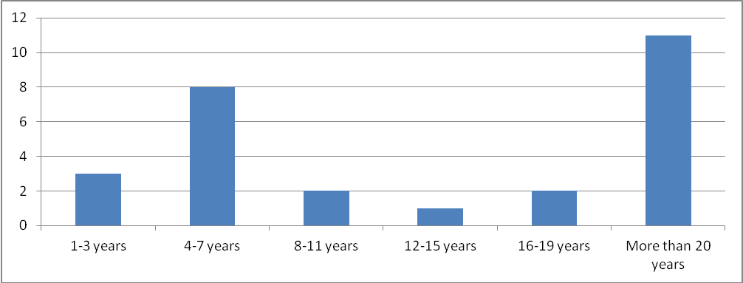
11%
30%
7%
4%
7%
41%

4.2 Farmer Profile

Farmers were asked about their stage of operation. 44% of farmers stated that they were growing/transitioning, 39% stated they were established, while 11% stated they were starting up and 6% winding down. See the chart below.

Pie Chart 4-1- Stage of operation: Farmers only
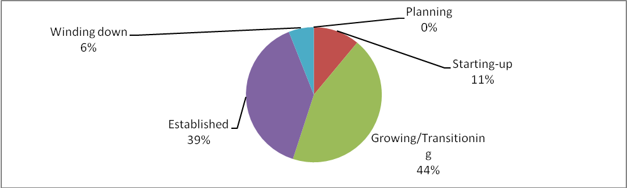

The average size of farms surveyed for our assessment was 79.3 acres or 32.1 hectares which, on average is significantly smaller than the 123.6 hectare average as stated in the agricultural profile (section 3.1). This was not a surprise because of our focus on mixed farming operations, small scale vegetable and fruit producers vs. large dairy farms. See the type of operation of the farmers we interviewed below. One surprise from the data was that while farmers have large amounts of land (79.3 acres on average) not a lot of that land is being used for fruit and vegetable consumption- only 6.1 acres on average for fruit crops and 0.92 on average for vegetables even though 61% of the farmers were interviewed were fruit and vegetable farmers.

Table 4-2- Type of Farm
Type of operation
Farmers Only
- selected
multiple responses
Fruit and Vegetable
61%
Fruit only
11%
Vegetable only
22%
Grain
6%
Livestock (layers, boilers, hogs, dairy, beef, sheep, etc…)
39%
Seafood
6% (Co-op)
It is also clear from our data that the income generated by farmers we surveyed remains low. This is consistent with data obtained from the Department of Agriculture in the spring of 2012. See the last paragraph of page 16 of this report.

Pie Chart 4-3- Annual gross value of all fruit and vegetables produced: Farmers only
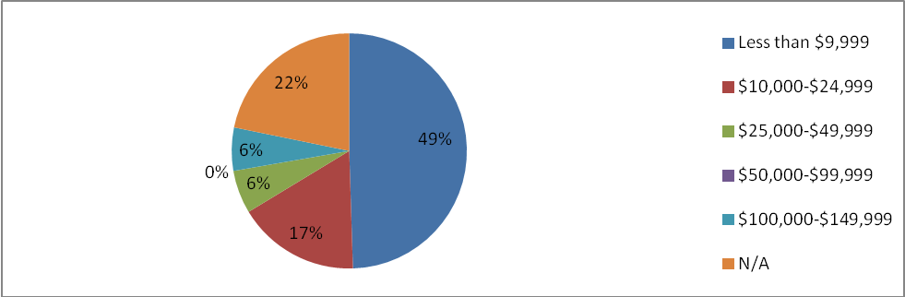

Income generated seems to be split fairly evenly between vegetable and fruit production.

Table 4-4- Gross Income by commodity
Gross income by commodity (farmers only) | Mean | Median | Mode
Fruit (11 Responses) | 48% | 45% | 10% - 100%
Vegetable (12 Responses) | 52% | 46% | 10% - 100%

4.3 Market Assessment- All Local Food Producers (Fisherman, Farmers, Processors)

What local food products are available in the region?

The most frequently identified products that farmers indicated they sell for market are fruit (apples, blueberries, rhubarb, strawberries, and plums), vegetables (beans, beets, lettuce, carrots, peas and tomatoes), animal protein (beef, pork, lamb and chicken), grain (buckwheat flour, wheat flour) and herbs (mint, parsley, thyme, basil, chives, dill, oregano and sage). Value added or plate ready products sold include pickles, jams and jellies and baked goods.

Table 4-5- When are local food products available in the region? The table below summarizes the data related to time of year availability.

Months of the year with product available
Fishermen
Producers

SUM
January/February
---
13%
4%
March/April
---
13%
4%
May/June
100%
13%
52%
July/August
100%
13%
59%
September/October
100%
25%
67%
November/December
---
13%
44%
Year long
---
63%
26%
N/A
---
13%
4%
*Producers include both farmers and food processors

Only 4% of producers have product available between the months of January and April. Come spring (May and June) 52% of producers have local product available. This percentage increases again to 59% and 67% during the summer and fall months of July and August and September and October, respectively. During the winter months of November and December, 44% of producers still have product available and a reasonable 26% of producers have product available year round. See table 15b-4.1) in appendix for a visual breakdown.
This data does not differentiate between what types of products are available when and in what quantity. However, it can be generally assumed that the increased numbers from May to November indicate the seasonal production of fruit and vegetables while the December to April and year-long availability stats indicate processors (meats, eggs, dairy, and grains).
Table 4-6- What type of local food products are available?

Description of Products
Farmers
Fishermen
Processor
SUM
Local
100%
100%
100%
100%
Farm/Family owned
94%
100%
100%
96%
Non organic/wild
61%
100%
38%
56%
Certified organic
---
---
25%
7%
Conventionally grown/commercial
11%
100%
25%
19%
Biodynamic/permaculture
28%
---
---
19%
Pasture to plate
11%
---
25%
15%
Non-medicated
22%
100%
50%
33%
Free run/free range/ pastured
22%
---
25%
22%
Natural
72%
100%
63%
70%
Hormone free
17%
100%
50%
30%
Sustainable
78%
---
63%
70%
OTHER
(Self-identified)
Provincially inspected
---
---
38%
11%
Federally inspected
---
---
25%
7%

This table illustrates the number of local, family owned businesses in our region (96%). We also have a very high percentage of producers who use sustainable practices within their business. This may serve as a marketing advantage if a local food marketing campaign was undertaken.

Table 4-7- What marketing outlets are used by local food producers?

Marketing outlets used in NENS
Farmers
Fishermen
Processors
SUM
Farmers Market
67%
---
50%
59%
CSA
38%
---
13%
30%
On-site sales
78%
100%
100%
85%
Direct to retailers
44%
---
100%
59%
Direct to institutions
11%
100%
38%
22%
Direct to restaurants
50%
---
88%
59%
Direct to distributors
11%
100%
38%
22%
Direct to processors
22%
100%
25%
26%
OTHER
---
---
25%
7%
Direct marketing appears to be the most preferred channel for farmers in our region. Processors by comparison tend to be more flexible and willing to deal with wholesale and institutional markets. Fishermen, being such a heavily regulated industry that generates significant export earnings, have many barriers to direct marketing.

Bar Graph 4-8- Marketing outlets used in NENS: Sum of producers (multiple selections)
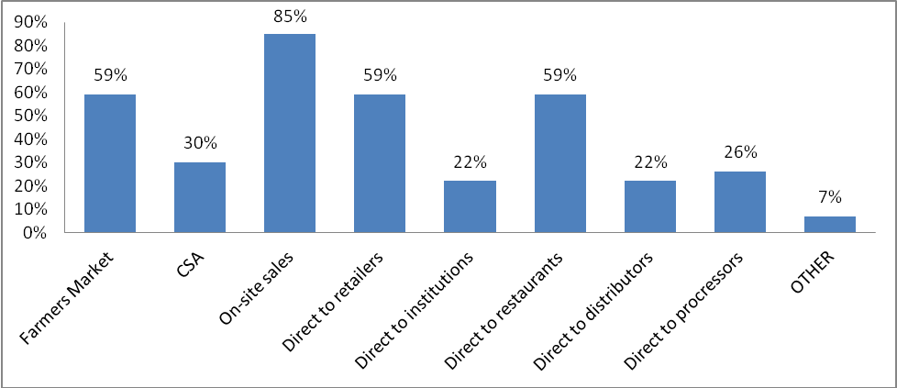

Table 4-9- What percentage of products are sold within the region?

The majority of local producers claim to sell the majority of their product within the region. On the other hand, a greater number of processors tend to seek markets outside of the region, most of the seafood products are exported outside of province.

4.4 Market Expansion

We were very interested in aspects of market expansion for market food as we see opportunities that exist in our region. What did food producers think?

Bar Graph 4-10- Do sufficient incentives exist to encourage you and others to grow and expand operations? (Y=# of producers)
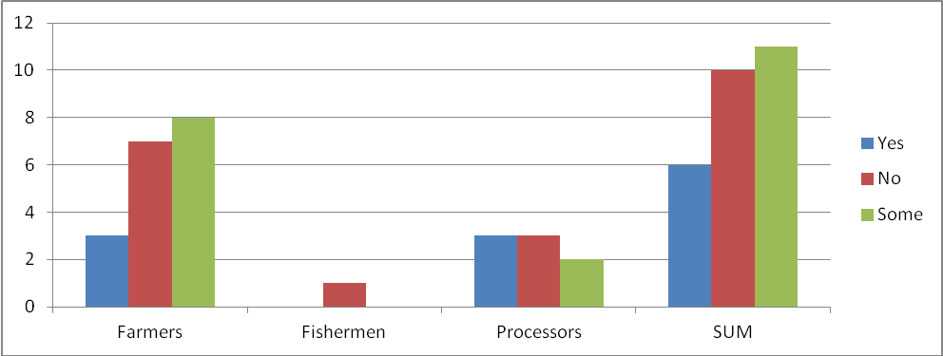

Only 22% of producers (6/27) stated that sufficient incentive exists, 37% of producers (10/27) stated that sufficient incentives do not exist, 41% of producers (11/27) stated that only some incentive exists. Fishermen’s ability to expand operations is supply managed and is determined by the quota system.

Table 4-11- Do food producers want to expand operations?

Do you have the capacity and would you like to
expand if the opportunity existed?
Farmers
Fisherman
Processors
SUM
I have the capacity but no desire to expand
11%
0%
0%
7%
I do not have the capacity nor do I have desire to expand
6%
0%
0%
4%
I do not have the capacity but I would like to expand
22%
0%
13%
19%
I have the capacity and I would like to expand
61%
100%
88%
70%
Close to 90% of producers stated they would like to expand while, 70% of those claim to have the capacity to do so and the other 19% would like to expand but state they do not have the capacity.

Table 4-12- By what capacity can food producers expand?

If opportunity existed, by what percentage
could you increase your operation?
Farmers
Fishermen
Processors
SUM
Less than 20%
22%
0%
25%
22%
21-40%
26%
0%
13%
26%
41-60%
7%
0%
13%
7%
61-80%
4%
0%
13%
4%
81-100%
7%
0%
0%
7%
Greater than 100%
15%
0%
0%
15%
N/A (supply managed vs. not known)
19%
100%
38%
19%

Bar Graph 4-13 -What barriers exist?

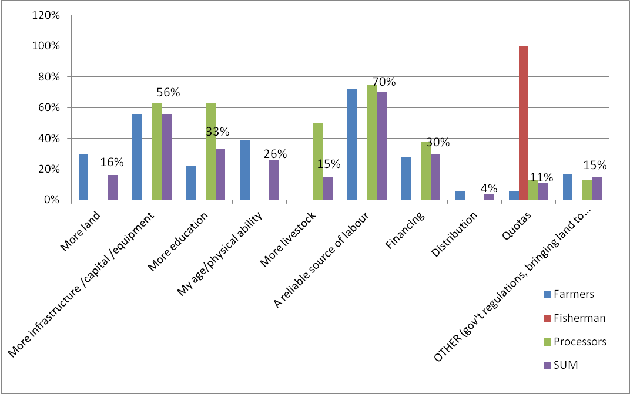

Finding a reliable source of labour, as identified by 70% of producers, was the largest barrier to expanding production, particularly for farmers and processors. Following labour was the need for more infrastructures/ capital/ equipment at 56%, the need for more training and education at 33%, the need for financial aid at 30%, age and physical ability at 26%, the need for more land at 16%, the need for more livestock at 15%, particularly for
processors, other (government regulations, the need to bring land to fertility, the need to clear land) at 15%, quotas at 11%, and lastly, distribution of product at 4%.

Table 4-14- Do food producers sell to local institutions and businesses? Are they interested in doing so?

Do you currently sell to any…..?

Farmers
Fisherman

Processors
SUM
Hospitals
6%
100%
13%
11%
Grade schools
0%
0%
13%
4%
University
0%
100%
38%
15%
Nursing home
11%
0%
13%
11%
Restaurants
44%
0%
88%
56%
Daycare
6%
0%
13%
7%
Market/Vendors
44%
0%
100%
59%
I do not sell to any institutions
28%
0%
0%
19%
Table 4-15- Interest in selling to institutional buyers
Would you be interested in selling to
additional institutional buyers in the region?
Farmers
Fishermen
Processors
SUM
Very interested
28%
100%
75%
44%
Interested
33%
0%
25%
30%
Neutral
22%
0%
0%
15%
Not interested
38%
0%
0%
11%

It is clear that farmers sell very little product to local institutions such as the hospital and the university. Their largest markets are restaurants and direct marketing at the Farmers Market. Fishermen are the opposite of farmers in that they sell to hospitals and the local university but not to other markets such as restaurants. Processors are similar to farmers in that their largest market is to restaurants or through direct sales. It is also clear that very little local food is being sold to local school cafeterias. These results clearly highlight that there are potential opportunities for local food producers to access additional local markets for their product. This is also supported by the fact that 61% of farmers are either very interested or interested in selling to institutional buyers, 100% of fishermen are very interested and 100% of processors are either interested or very interested.

Table 4-16- Liability Insurance

Do you carry product liability insurance?
Farmers
Fishermen
Processors
SUM
Yes
28%
100%
88%
48%
No
72%
0%
0%
48%
N/ iechart 4-19 of Farm by commodity l buyerse?A
0%
0%
13%
4%

72% of farmers did not carry product liability insurance. However, as our assessment was focused on relatively smaller operations this is not a surprise. As well, many of our farmers sell their product through direct sales which does not require liability insurance. This may be something that needs to be explored if larger product markets were created (i.e. to large institutions like the university).

Table 4-17- Amount of liability insurance

If yes, how much liability insurance do you carry?
Farmers
Fishermen
Processors
SUM
Less than $1 million
0%
0%
0%
0%
1-2 million
11%
100%
25%
19%
3-4 million
0%
0%
13%
4%
5 million or greater
6%
0%
13%
7%
N/A
83%
0%
50%
70%

What are the barriers and/or challenges associated with supplying institutional/ wholesale markets? Farmers only

The top six barriers/challenges ranked by farmer producers are:

- Government policy and regulation
- Meeting Quality and Safety Standards
- Getting a fair price
- Seasonality of supply
- Supplying Large quantities
- Providing product liability insurance

See Bar Graph 4-18 below.

Bar Graph 4-18-Barriers to accessing Institutional Markets

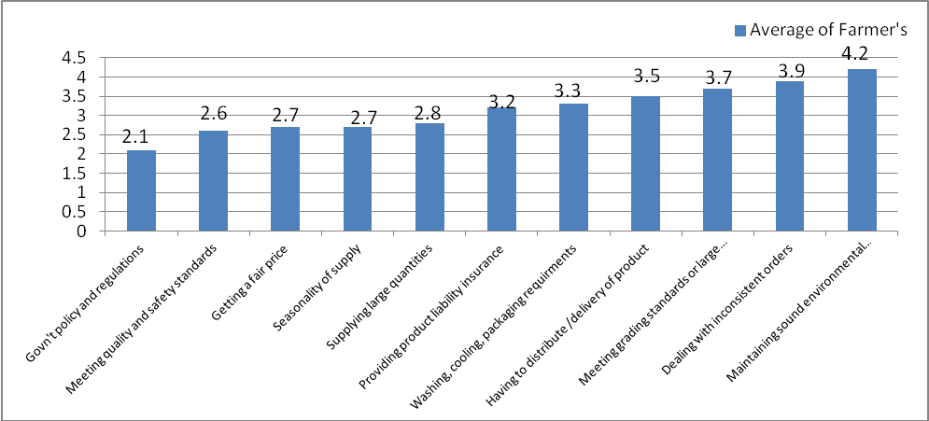
1= Major Barrier, 5= Not much of a barrier

Additional barriers/challenges that were noted within the key informant interviews were the ability to store product, dealing with the contract pricing structure and the scale that central distribution centers require is too large for small producers. Some farmers also mentioned the tilted playing field and the difficulty for small producers to compete with large corporate producers.

Processors and Fisherman were similar to fisherman in that they both identified government policy and regulation as their primary barrier to supplying institutional and wholesale markets.

Charitable Food Giving by Food Producers

58% of producers stated that they would be interested in donating to the food bank or to some other charitable organization in some form or another. 20% of producers were not interested, 15% of producers already donate and 7% did not respond.

Pie chart 4-19 Percentage of producers interested in donating to the food bank or to some other charitable organization: Sum of producers
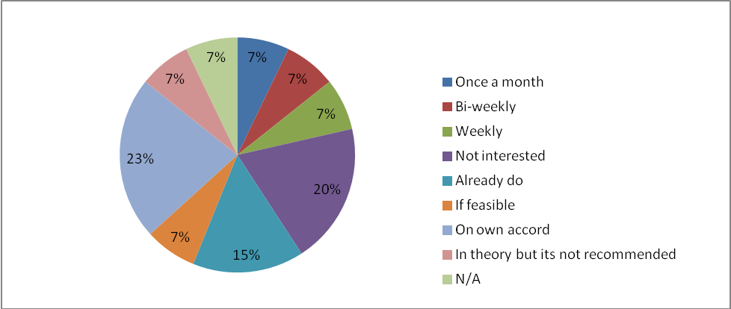

Percentage of producers who support a community gleaning organization: Farmers only

66% of farmer producers stated that they would support a community gleaning organization, only 6% responded stating no, they would not support a community gleaning organization and 28% did not respond. With 66% (possibly more) of producers supporting the idea of a community gleaning organization there is an opportunity to harvest producers’ excess food crops. Products harvested can be donated to community food banks or other charitable organizations.

5.0 Buyers Survey Results

5.1 Demographics of Respondents

On the buyer side of our community food assessment surveys, we accumulated 127 surveys all together. 103 of the respondents were individual consumers who completed the survey independently. Face to face surveys were completed with 15 institutions and businesses and 9 existing food retail locations (vendors). As stated previously in this report the institutions and businesses consisted of those who sell prepared food products such as the food service within the local hospital, food service within the local school, some local restaurants, food service at St. F.X. and others. The vendors (food retail locations and supermarkets) consisted of those who sell both prepared and unprepared food products (i.e. where people can buy food to take home to prepare). Examples of vendors would include supermarkets, one local food store, convenience stores that sell food in rural locations. The term “wholesale buyers” in this report refers to all of the buyers we surveyed (Institutions and Businesses, Food Vendors) excluding the individual consumer group.

Table 5-20
Buyers’ respondents (TOTAL)
127
100%
Individual Consumers
103
81%
Institutions and Businesses
15
12%
Vendors and Supermarkets
9
7%
Table 5-21
Residence/Location of buyers
Consumers
I&B
Vendors
SUM
Antigonish Town
35%
67%
44%
39%
Antigonish County
55%
13%
11%
47%
Guysborough County
5%
20%
33%
9%
Inverness County
4%
0%
0%
3%
Pictou County
2%
0%
0%
2%
As can be seen in this table a large percentage of the consumers, institutions and businesses and vendors were from either Antigonish or Antigonish County. This is largely in part to the fact that the town of Antigonish is the largest centre in the region (based on population) and has a larger number of institutions/businesses and vendors. However, we were able to talk to some vendors from Guysborough County.

How do local buyers define local? Buyers’ perceptions regarding local food

Bar Graph 5-22 - Defining “local” product as found within:
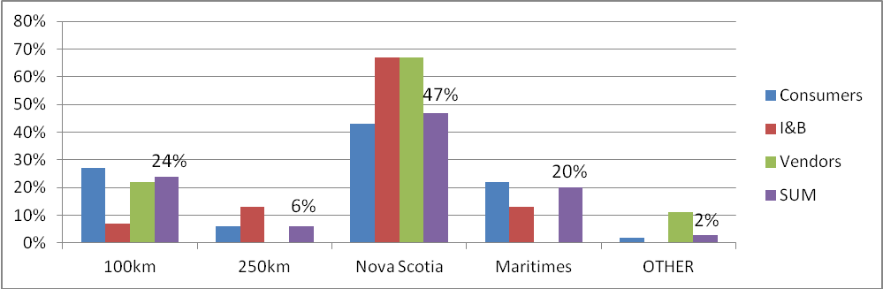

The largest portion of buyers define local as found within Nova Scotia. Although it is clear from this graph that there are variations in what those surveyed define as local with 24% stating it is food within 100 km, 20% stating it is food from the Maritimes (provinces of Nova Scotia, PEI and New Brunswick).

What do buyers see as the advantages of buying local food?

Table 5-23- Perceived Advantages of purchasing locally sourced food (Average rankings) for all food buyers

Rank from 1 -5  1= Major Advantage  5- Minor Advantage | Consumers | Institutions  and  Businesses | Vendors | SUM  (average rating by all buyers)
Supports local farmers | 1.16 | 1.07 | 1 | 1.14
Supports local economy | 1.23 | 1.07 | 1 | 1.19
Purchasing local helps build community | 1.25 | 1 | 1.11 | 1.21
Promotes sustainable agriculture | 1.26 | 1.2 | 1.44 | 1.27
I like to know the source of my food | 1.34 | 1.4 | 1.11 | 1.33
Local food is fresher | 1.7 | 1.3 | 1.55 | 1.64
Local food has more flavour | 1.7 | 1.9 | 2.44 | 1.78
Local food has greater nutrition | 1.87 | 2.53 | 2.44 | 2
Promotes positive public relations | 2.16 | 1.6 | 1.44 | 2.03

All buyers generally understand the advantages of purchasing locally. Compared to individual consumers, some vendors do not see local food as necessarily having more flavour. Wholesale buyers do not rank the advantage of greater nutrition as high as other advantages. Wholesale buyers agree that providing local food in their services promotes positive public relations. Other advantages of purchasing locally that were recorded (either individually completed or done in interviews) included having a better idea/ being more certain that products are not genetically modified, knowing how that product was produced or grown (i.e. whether pesticides were used, labour standards being practiced, treatment of animals).

What do buyers see as the disadvantages of buying local food?

Table 5-24- Perceived Disadvantages of Purchasing Locally Produced Food (Average rankings) for all food buyers

Perceived Disadvantage  Rank from 1 to 5  1=Major Disadvantage  5= Minor Disadvantage | Consumers | Institutions and Businesses | Food Vendors
Not enough public awareness or support | 2.2 | 1.7 | 2.5
Availability is too limited | 2.4 | 1.4 | 2.1
Need for guaranteed supply; supply is too unreliable | n/a | 1.9 | 2.1
No uniform or standardized packages | n/a | 4.2 | 3.8
Accessing and finding local food to purchase is difficult | 2.7 | 1.9 | 2.4
Too expensive | 2.8 | 2.5 | 3.3
Preparing local food is inconvenient and time consuming | 3.8 | 3.7 | 2.4
There is not enough consumer demand | n/a | 3 | 3.6
Quality and safety standards are not sufficient | 3.8 | 2.7 | 3.7
Lack of knowledge, skills to prepare fresh, raw, whole product | 3.8 | n/a | n/a
Presentation and appearance are not up to my standards | 3.9 | 4.3 | 3.4

There were no major surprises in this data and it was good to see that the higher rated disadvantages that can be overcome such as public awareness and availability. 25% of all institutions, businesses and supermarkets also identified the lack of variety, the absence (or insufficient levels) of product liability insurance and the requirements of federal and provincial inspections as disadvantages and challenges for purchasing locally produced food.

The following data analysis is broken up into three sections to show the results of the surveys completed by individual consumers, institutions and businesses and vendors and supermarkets.

5-2 Survey Results for Individual Consumers

80% of the individuals who completed our survey were female, 17% were male and 3% were of an unknown gender. The individuals who completed the survey ranged widely in age. As stated in the methods we did not attempt to complete an individual survey that would represent the population as a whole but as a way for us to test some of our assumptions and use the data in our community conversations (i.e. Reveal what the consumers we surveyed told us and check assumptions).

Pie Chart 5-25 - Age of individual consumers
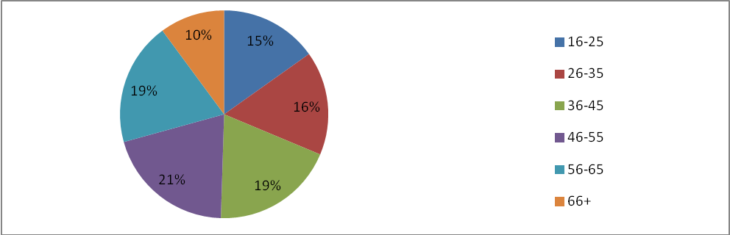

Distance from nearest supermarket: Individual consumers

41% of individual consumers are within 5km from the nearest supermarket, 18% between 5km and 10km, 14% between 11km and 15km, 11% between 16km and 20km, 9% between 21km and 30km, and 7% of individual consumers traveling more than 31km; 2% did not respond.

Pie Chart 5-26- Number of Individuals per Household- Individual Consumers Only

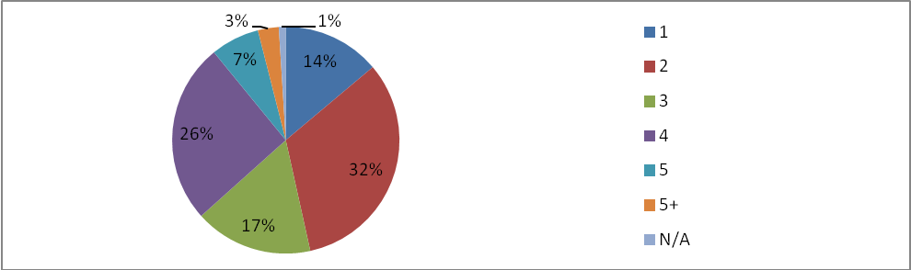

Table 5-27- Income earners per household

Income earners per household:
Individual consumers only
1
34%
2
54%
3+
8%
4
N/A
Pie Chart 5-28- Household income: Individual consumers only
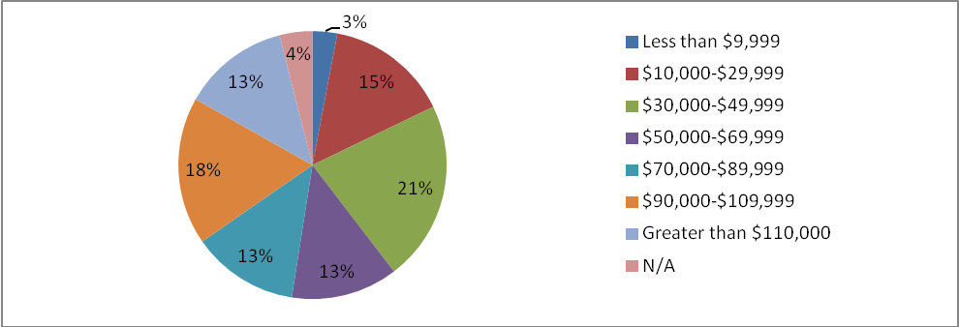

As can be seen in these pie charts and tables the individuals who completed the survey came from a variety of households with regards to the number of individuals, number of income earners per household and household income.

What percentage of household income are individuals spending on food?

Table 5-29- Percentage of household income spent on food

Percentage of household income spent on food:
Individual consumers only
0-10%
6%
11% - 25%
61%
26% - 50%
23%
51% - 75%
4%
Greater than 76%
0%
N/A
6%
Method of transportation to and from supermarket: Individual consumers only

The vast majority, 83% of individual consumers use their own vehicle to commute to and from supermarket. The remaining 17% use various means from ride shares to walking. It should be noted that there is not public transportation available in our region.

Are individuals aware of the local food guides?

Pie Chart 5-30- Awareness of available local food guides: Individual consumers only
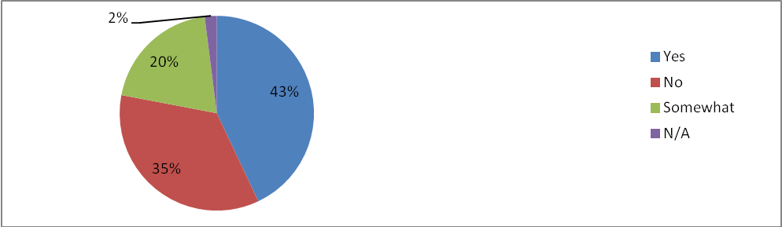

63% of individual consumers were aware or somewhat aware of the available local food guide in the area.

Do individual consumers think it’s important to have access to fresh local food?

Table 5-31 Importance of access to fresh local food- Individual Consumers
Very Important
72%
Important
25%
Neutral
1%
Not Important
0%
N/A
2%
97% of individual consumers think it is either very important or important to have access to fresh local food. No one responded stating that they did not think it was important.

What would individuals be willing to spend on a local food item if the same item costs $1.00 at the supermarket?

The largest portion of individual consumers responded claiming that they would be willing to spend 25% more for a $1.00 local product and 26% would agree to pay 50% more. 3% would agree to pay 10-20% more, 24% stated that they would expect to pay the same if not less and 8% did not respond.

Pie Chart 5-32- What individuals expect to spend on a local food item if the same item costs $1.00 at the supermarket: individual consumers only
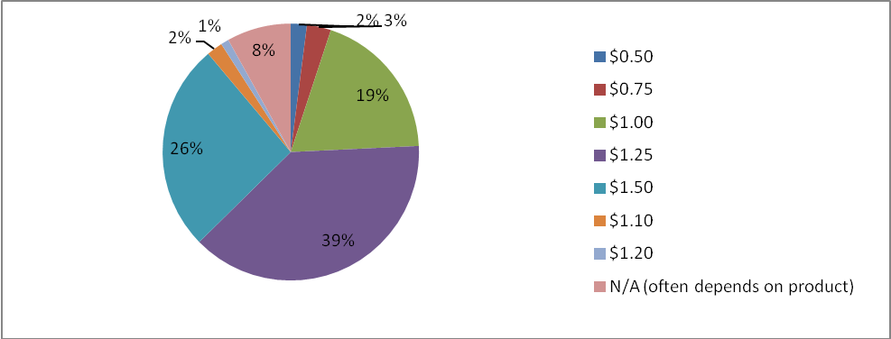

Are buyers’ perceptions similar?

Bar Graph- 5-33- Buyer estimates of how much more consumers are willing to pay for local product: (Y= % of buyers / X= % (buyer presumption) excluding individual consumers
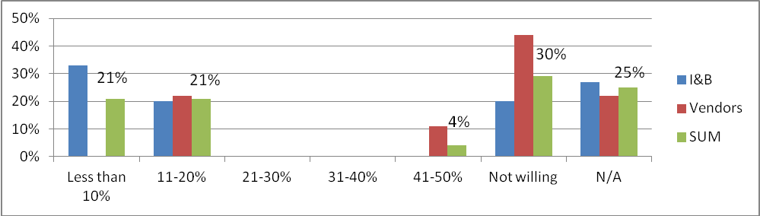

When we asked buyers (excluding individual consumers the same question (i.e. how much more individual consumer would be willing to spend on a comparable locally sourced product), 42% responded stating that they could expect consumers to spend up to 20% more. Wholesale buyers believe individual consumers are less willing to spend more on a local product than individual consumers themselves claim. It should be noted however, that this could due to the fact it was judged on the evaluation of a $1 product only. However, this could be an area for further research as perceptions do not appear to be the same.

Percentage of individual consumers who self-produce, would be interested in self-producing and/or producing for others

72% of individual consumer respondents already produce some of their own food, for themselves or for themselves and others. 20% of respondents showed interest in self-producing or producing for themselves and others. Only 6% of respondents did not show any interest in self-producing or producing food for others.

Pie Chart- 5-34 -Percentage of individual consumers who self-produce, would be interested in self-producing and/or producing for others

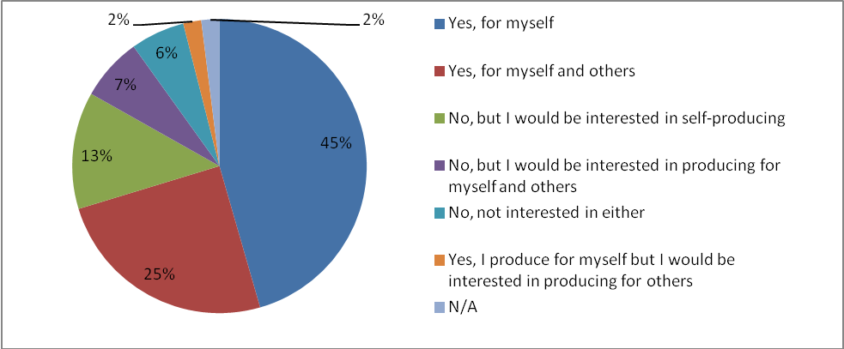

How do individuals access local food?

Most used method of accessing local product: Individual consumers only

40% of individual consumers identified the farmer’s market as the most used method of accessing local food, 30% identified the supermarket, and 20% stated self-production while 10% stated the Co-op. No respondents stated community shared agriculture, restaurants, or direct from farm gate, u-picks or on-site sales.

What influences individuals food purchasing decisions?

We asked individuals to rate the following characteristics.

Table 5-35- Influences on food purchasing decisions: Rated by consumers from 1= always true to 5=Never True
Characteristic | Rating
Level of Freshness | 1.6
Healthy and nutritious options | 1.8
Preference where I shop | 2.2
Sustainably grown or produced | 2.1
Natural Products | 2.1
How far the food travels | 2.5
Convenience | 2.6
Cheapest Options | 2.8
Non organic/wild products | 3.1
Habit | 3.3
Free range/free run/pastured animal products | 2.4
Hormone free/non-medicated animal products | 2.4
Certified organic products | 2.9

It was surprising that price (cheapest options) was not rated higher on this list but this could be due to the demographic of people we surveyed. However, as level of freshness and healthy/nutritious were rated quite high there is potential to use this to market local food in our area. Other influences that effect the food purchasing decisions such as, the ability to have product delivered, that product meets a set of legal requirements, product sales and promotions, being a part of a buying group, and head office procurement were also listed but not ranked.

5-3 Results for Institutions/Businesses and Vendors Only (Wholesale buyers)

Individuals served per day and importance of buying local

The majority of wholesale buyers, 71% serve between 50-300 people. This is due to the fact that we surveyed a large number of restaurants and/or cafés. 20% of wholesale buyers serve between 401 and 2000 customers/clients and only 4% serve more than 2000. 4% of wholesale buyers did not respond. 88% of the buyers we spoke to see buying local as important to their customers and clients.

Existing buy local procurement policies

92% of wholesale buyers do not have a buy local procurement policy in place but claim to make an effort to support local.

Total annual gross value of all food items purchased

The largest portion of wholesale buyers at 33% purchase up to $24,000 of food annually, 25% claimed to purchase between $100,000 and $999,999, 21% claim to purchase over $1,000,000 and another 21% did not respond.

Do buyers have any budget flexibility for purchasing local food?

We asked institutions and businesses and vendors to rate how flexible their budget was when it came to purchasing local food.

Bar Graph 5-36 Budget flexibility for purchasing locally
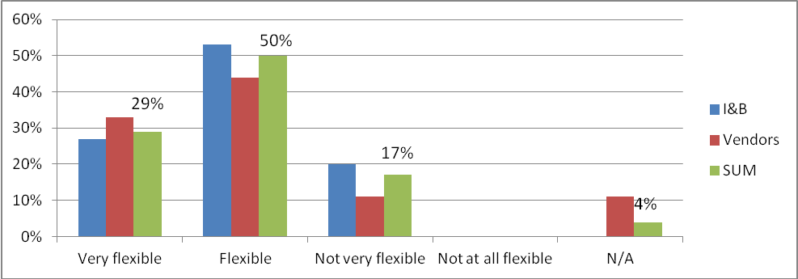

It appears that there is flexibility in the food budgets of wholesale buyers to purchase locally produced foods. No buyers indicated that their budget was not at all flexible. Institutional buyers express less flexibility than food vendors when it comes to purchasing locally produced food.

How much of the food they purchase is from local producers?

Percentage of food that is sourced from local producers

56% of wholesale buyers claimed to source up to 40% of their product from local producers, 24% claimed to source between 41% and 80%. 12% claimed to source between 80% and 100% and 8% of wholesale buyers did not respond. As this is self-reported data there is potential for these numbers to be higher than the actual percentage of local food used.

Have local buyers noticed a change in the amount of local food being sold over previous years?

Bar Graph 5-37-Change in amount of local food being sold compared to past years: (Y=% of buyers / X= change)
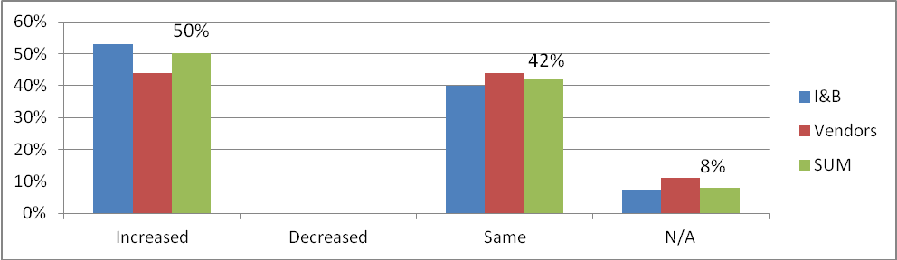

50% of wholesale buyers claim to have increased the percentage of local food being sold/served compared to past years while 42% claim that levels have remained the same. No buyers indicated a decrease and 8% did not respond. Institutional/Business responses indicate that a slightly higher percentage of local food is being served compared to past years than food vendors.

Are your clients/customers requesting that more local product be available?

Bar Graph 5-38- Clients/customers requesting that more local product be available
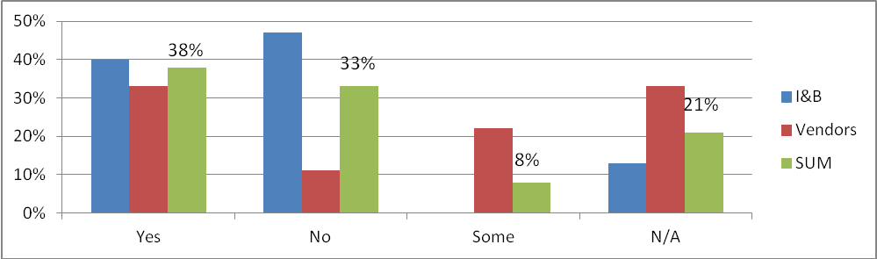

46% of wholesale buyers state that at least some of their customers and clients are requesting that more local product be available. 33% stated that no, clients/customers are not requesting for more local product. 21% of wholesale buyers did not respond. At a glance, it appears that institution and business clients/customers are less inclined to make request that more local foods be available compared to vendor clients/customers. This could be directly related to the lack of clients/customer input/feedback mechanisms at large institutions, for example, schools, universities, hospitals, extended care facilities.

Bar Graph 5-39 -Are consumers willing to pay more for local product? (Wholesale buyers’ perceptions)

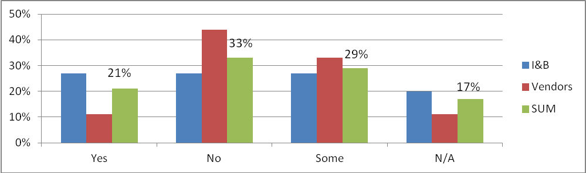

21% of wholesale buyers responded stating yes, they assume that at least some of their consumers are willing to pay more for local product while 33% responded no. 17% of wholesale buyers did not respond. A higher number of institutional buyers and businesses state that consumers are willing to spend more on local food than food vendors.

Kitchen size and ability to prepare (fresh/raw) local product

73% of buyers reported that they have a kitchen that allows them to prepare fresh/raw local product. 20% have limited ability and 7% do not have a kitchen.

Clear labelling of local product: Vendors and supermarkets only

The majority, 56% of vendors and supermarkets claim to clearly label local product (it was unclear to the researcher what the vendor considered to be clear labeling). 11% admitted to not clearly labelling local and 33% did not respond.

Local food advertising: Vendors and supermarkets only

When asked if local food was advertised 78% of vendors and supermarkets responded that it was. 6 food vendors (67%) responded that they advertise local produce in store. One stated they advertise local product on the radio and another vendor mentioned they advertise local product through distributed flyers. 22% did not respond to this question.

What influences wholesale buyers food purchasing decisions?

Table 5-40- Influences of Food Purchasing Decisions: Institutions and Businesses and Vendors, 1= Always True 5=Never True
Influence | Institutions and Businesses | Food Vendors
Level of Freshness | 1.3 | 1.3
“I try to buy locally produced food whenever and wherever I can” | 1.4 | 1.4
Healthy and Nutritious Options | 1.5 | 2.4
Preference where I shop | 1.9 | 2
Sustainably grown/produced | 2.1 | 2.6
Natural Products/products that contain natural ingredients | 2.5 | 2.6
Cheapest Options | 3.1 | 3.6

Similar to individual consumers it was surprising that price; “cheapest options” was not ranked higher.

How much liability insurance is required by wholesale buyers for local food?

58% of wholesale buyers claimed to not require any product liability insurance, 8% require between 2 and 5 million, and 30% did not respond/were not sure. 4% only require product liability insurance on meat products. It should be noted that a significant portion of those who answered “none” are restaurants and small scale or independent retailers (not large institutions).

Do buyers have flexibility in what products and quality standards they can accept?

Bar Graph 5-41 -Flexibility in what products and quality standards buyers can accept: (Y= % of buyers) excluding individual consumers
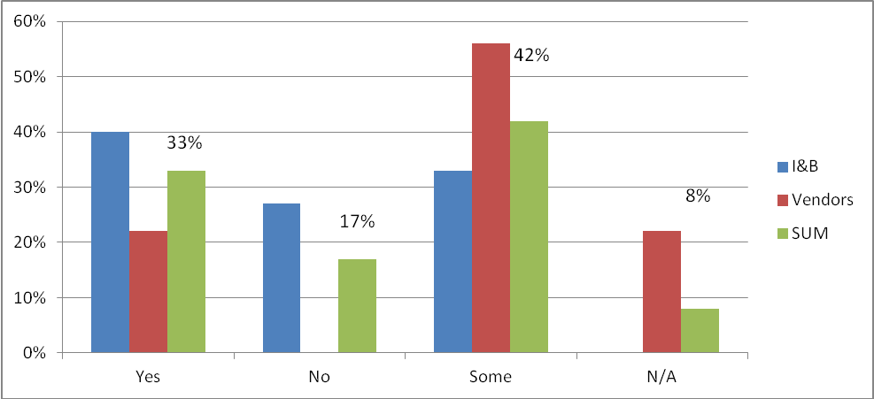

75% of wholesale buyers indicated at least some level of flexibility in what products and quality standards they would accept (33% yes, 42% some). 17% stated that there was no flexibility and 8% did not respond.

What local products are wholesale buyers purchasing most frequently?

Results revealed that the following were the most purchased items:
Top three fruit- Strawberries, Blueberries and Apples
Top four vegetables- Lettuce, carrots, tomatoes and potatoes
Top four protein choices- seafood, eggs, pork
Top four dairy items- milk, ice cream, cheese
Top two grains: bread and rolls
Herbs- nothing significant purchased
Others identified- maple syrup, honey, jams and jellies

What local products, if available are buyers most interested in purchasing?

Table 5-42- Top Five Local Products to Purchase by Buyers
-What locally sourced products, if available and easily accessible
would you be most interested in purchasing?
TOP 5 by SUM of buyers
SUM
Apples
50 (56%)
Cheese
44 (49%)
Strawberries
43 (48%)
Blueberries
41 (46%)
Beef (steak, ground, roasts)
38 (42%)
Maple Syrup
38 (42%)

Although vegetables were not in the top five buyers indicated they would be most interested in carrots, broccoli, lettuce, tomatoes and potatoes in this category. In the grains category granola and local flour were also listed.

It should be noted that the top three categories that producers would like to sell more of include:

Vegetables- beans, carrots, greens
Fruit- plums, strawberries, blueberries
Other- cheese, beef product, pork product

What risks do wholesale buyers see with sourcing and selling/serving local product?

Table 5-43- Average percentage of wholesale buyers who identified one of the following risks Please note: These items were self-identified (open question)

What do you consider to be the largest risks associated with sourcing
and selling/serving local product?
Wholesale buyers only - self-identified

Average # of
Buyers
Lack of supply, availability, not getting the product
46%
Contamination, food safety, safe food handling
25%
Quality of product
17%
Certifications
13%
Distribution challenges
8%
Cleanliness
8%
Cost
4%
Methods of payment
4%
People will talk to talk but not act on their words
4%
N/A
21%

This data reveals the importance of ensuring a reliable supply of local food for wholesale buyers. Challenges related to food safety will also have to be overcome if more local food is to become available to institutions, businesses and vendors.

5-4- Food Security- What can be done about it in our region?

We asked all producers and wholesale buyers to answer a question about what could be done about the issue of food security in our region (NENS). This table demonstrates the top 15 choices selected by those we surveyed.

In your opinion, what would you consider to be the most effective
ways of increasing the level of food security?
TOP 15 - Self-identified
SUM OF BUYERS AND
PRODUCERS
Increased public awareness and knowledge of associated benefits of local food
38%
Greater government support at all levels for local food initiatives
27%
If grocery stores and local institutions were more flexible with the suppliers and scale
they accept
25%
Greater incentive and reward for producers to increase production
21%
Attract new producers/suppliers/processors
21%
Self-production
18%
Empowering consumers to support local/small scale
17%
Local food marketing/branding/advertising strategy
16%
Establishment of a local food depot or Co-op to aggregate and distribute local food
products
16%
Get school board involved (agriculture, cooking, gardening classes)
14%
More training programs and workshops for producers/suppliers
12%
Greater collaboration among producers
11%
Better access to info on industry policy and regulations
10%
More nutrition education programs and food skill building
8%
New and improved Farmer's Market/space to sell direct
8%

6.0 Challenges and Opportunities for local food in Northeastern Nova Scotia

This report takes an in depth look at the local food economy in our region of Northeastern Nova Scotia. The aim of the project was to assess the local food system and value network in NENS and to establish a foundation for the development of further projects in our area. One of the primary objectives of the project was to evaluate the supply and demand of local food and to identity both the existing and potential challenges and opportunities in the regional food system.
Upon completion of the data collection and analysis the Antigonish Food Security Coalition reviewed the information at our monthly meetings between September 2012 and February 2013. The information we gathered confirmed some of our previous assumptions and provided us with new information about local food in the area. However, we needed to strategically ask ourselves what are the specific challenges we can actually influence? How can this information allow us to move ahead with taking action in the region? This process has enabled us to focus on some of the key opportunities and challenges that we see in the region and in Nova Scotia. We also feel this information will be highly valuable as we move forward in educating partners and members of the community.

Opportunities

1) There is clearly a desire for local food in the area by individuals, producers and wholesale buyers.

2) Our region has agricultural land which is not all being utilized. There is a desire by some producers to expand their operations. How can local food contribute to economic growth in the region? How can we support producers to expand?

3) Although there is increased awareness of local food in the community, many of the producers and wholesale buyers we spoke to talked about the need for further community education on this issue.

4) There are many existing programs and projects that are addressing some aspect of the local food movement in the area. One of these projects includes a recent development by the Bethany motherhouse through the Sisters of St. Martha to support small food producers through land leasing and education, The Bethany Garden Apprenticeship Program. How can we build on programs such as this? What is our unique role?

5) There is a need for more local food in local institutions, food businesses and supermarkets (including schools). This has huge potential for local producers in terms of their desire to expand.

6) There is no food store or food vendor in the downtown core of Antigonish that is in walkable distance for students/seniors in the area. This is both a challenge and an opportunity!

7) The Antigonish Food Security Coalition is part of a wider network of individuals and organizations doing this work in Nova Scotia. Are there other provincial partners we can work with to improve the distribution of Nova Scotia food within the province?

Challenges

1) Supply! It was obvious throughout the assessment that the region does not have enough local food to supply institutions and businesses on a reliable and consistent basis. How can we increase the supply? What products could we access from across the province?

2) The issue of food safety/liability insurance came up consistently in our interviews with both producers and wholesale buyers (specifically the variety of certification processes and varying requirements by both food retailers and government). This is an issue that needs to be addressed on both a provincial and national level working with a variety of partners. How can we ensure a safe food supply while making it easier for local producers to access large markets?

3) The issue of labour supply came up consistently with the producers we spoke to (i.e. finding it difficult to access a reliable source of labour).

4) Support for people to go into farming or become local food producers was also cited as a challenge. It can be difficult to start a farm given the amount of land/equipment needed. We are hoping the new project taken on by the Bethany motherhouse can support some work in this area.

5) Competition with cheap imports. Producers and wholesale buyers also spoke to this issue and linked it with the idea of more education for the public.

7.0 Recommendations

Given all of the opportunities and challenges raised within this report what action could the Food Security coalition facilitate to improve access to local food in the region? After much discussion at our regular meetings we kept on coming back to the idea around a local food store in the downtown core of Antigonish. This was the initial reason for VOICES being formed and later the Food Security Coalition. While we cannot increase supply overnight to support large institutions or fix all of the food safety issues raised (long term process) can we create a successful retail location? This retail location could be one of the building blocks to later access larger markets for producers. Therefore, it would give individuals access to more local food, create another market for producers who want to expand and act as a food distribution hub (i.e. we could sell food from our own region but access other products from across Nova Scotia). As the business develops and scales up could we later act as a distribution centre for larger institutions? (i.e. become a hub where institutions/businesses could also buy local food)
In February of 2013 we hosted a community meeting to provide community members with some of the data we had obtained and to get their feedback on moving forward with a local food store (see meeting notes in appendix six). Community response to this idea was overwhelmingly positive as we had 40 people attend the meeting when there was another major community event happening on the same day (our initial date was cancelled due to a snow storm). Several people signed up to help move this initiative forward. Therefore, given the opportunities and challenges we identified and the community response to the idea of a local food store in downtown Antigonish we recommend the following:

- That the Antigonish Food Security Coalition along with provincial partners such as Select Nova Scotia (Department of Agriculture) continue its’ education efforts in the community regarding local food (i.e. through hosting local food events, social media- facebook page, local newspaper etc.).

- That the Antigonish Food Security Coalition explores the idea of a local food store in downtown Antigonish. This should be done in partnership with interested community members (possibly through a coordination committee) and interested producers. This group should look at existing resources in this area (i.e. who has done this that we can learn from?) and look at food distribution networks that currently exist across the province. (i.e. Who can we partner with in this regard)? This will allow for a greater supply of local food in our region.

- That the Antigonish Food Security Coalition offer support to the new program starting at the Bethany Motherhouse, Bethany Garden Apprenticeship program to support new food producers.

- That the Antigonish Food Security Coalition continue to link with provincial and national partners (i.e. Provincial Food Security Network, Department of Agriculture, Food Secure Canada) to advocate around issues that are affecting small food producers (i.e. varying food safety standards, labour supply, centralized food distribution systems).

- That the Antigonish Food Security Coalition continue to partner with the Antigonish Poverty Reduction Coalition to address the issue of food security for people living on low incomes. This may involve building on opportunities identified in this report such as a community gleaning project.

The Antigonish Food Security Coalition gratefully acknowledges the financial support from the McConnell Foundation in completing this report.

BIBLIOGRAPHY & FURTHER READING

Belliveau, A., Burbidge, E., Cantafio, J., Gazibara, N., Thomas, B., & Thompson, T. (2011), Food Security in Nova Scotia: Working Toward Resilient Communities, Halifax, NS: School for Resource and Environmental Studies, Dalhousie University.

Cunningham, G. and Fiander, K., (2009, May), By Their Own Hands: 200 Years of Building Community in St. Andrews, Nova Scotia, Occasional Paper Series (No. 7), The Coady International Institute, St. Francis Xavier University, Antigonish, NS.

Dietitians of Canada (2007), Community Food Security: Position of Dietitians of Canada, Retrieved from <http://www.dietitians.ca/Downloadable-Content/Public/cfs-position-paper.aspx>

Feed Nova Scotia (2011, March), Hunger in Nova Scotia, Retrieved from <http://www.feednova scotia.ca/hungerfacts_stats.html>

Go Local Enterprises (2011, March 30), Consulting Report: Mobile Farmer’s Market (report to examine the viability of the establishment of a mobile farmer’s market), Gerald Schwartz School of Business, St. Francis Xavier University, Antigonish, NS.

Government of Nova Scotia, Nova Scotia Community Counts: Antigonish County (2006), Retrieved from < http://www.gov.ns.ca/finance/communitycounts/profiles/community/default.asp? gnew=&table=&acctype=0&chartid=&mapid=&dcol=&sub=&ptype=geo&tid=&gview=3&glevel=cnt&yearid=2006&gnum=cnt1214>

Government of Nova Scotia, Nova Scotia Community Counts: Guysborough County (2006), Retrieve from < http://www.gov.ns.ca/finance/communitycounts/profiles/community/default.asp? gnew=&table=&acctype=0&chartid=&mapid=&dcol=&sub=&ptype=geo&tid=&gview=3&glevel=cnt&yearid=2006&gnum=cnt1213>

Government of Nova Scotia, Nova Scotia Community Counts: Inverness County (2006), Retrieved from < http://www.gov.ns.ca/finance/communitycounts/profiles/community/default.asp? gnew=&table=&acctype=0&chartid=&mapid=&dcol=&sub=&ptype=geo&tid=&gview=3&glevel=cnt&yearid=2006&gnum=cnt1215>

Government of Nova Scotia, Nova Scotia Community Counts: Pictou County (2006), Retrieved from < http://www.gov.ns.ca/finance/communitycounts/profiles/community/default.asp?gnew=& table=&acctype=0&chartid=&mapid=&dcol=&sub=&ptype=geo&tid=&gview=3&glevel=cnt&yearid=2006&gnum=cnt1212>

Guysborough Antigonish Strait Health Authority (GASHA): Antigonish Community Health Board (2010), Understanding our Health Final Survey Report, Antigonish, NS.

Guysborough Antigonish Strait Health Authority (GASHA): Community Health Boards (2010b, Spring), Community Conversations: Staying Healthy Together [Presentation].

Guysborough Antigonish Strait Health Authority (GASHA): Guysborough Community Health Board (2010c), Understanding our Health Final Survey Report, Antigonish, NS.

Guysborough Antigonish Strait Health Authority (GASHA): Strait Richmond Community Health Board (2006), Understanding our Health Final Survey Report, Antigonish, NS.

Hamelin, K., Ross, A., Wang, J., and Zhang, X. (2012, March): Creating an Appetite for Farming: An Exploratory Look at Immigration and Farming, Seniors at X Consulting, Antigonish, NS.

Knight, A. and Chopra, H. (2011), Growing Demand: Local Procurement at Publicly Funding Institutions in Nova Scotia, Nova Scotia Department of Agriculture/Nova Scotia Department of Fisheries and Aquaculture, Halifax, NS.

MacLeod, M. and Scott, J. (2010), Is Nova Scotia Eating Locally? And if Not, Where is Our Food Coming From?, Retrieved from < http://www.ecologyaction.ca/files/images/file/Food/FM%20July 4%20_ final_long_report.pdf>

Malhotra, K. (2010, February), Integrated Community Sustainability Plan: Town of Antigonish, Nova Scotia, Municipality of Antigonish.

McGean, L., Morrision, E., and Steele, L. (2012), Community Kitchen: Implementation of a Community Kitchen in Antigonish County, St. Francis Xavier University, Antigonish, NS.

Nova Scotia Department of Agriculture: Business Development and Economics Division, Agricultural Profile (2006): Antigonish County, Retrieved from <http://www.gov.ns.ca/agri/ bde/econ/AntigonishProfile.pdf>

Nova Scotia Department of Agriculture: Business Development and Economics Division, Agricultural Profile (2006): Guysborough County, Retrieved from <http://www.gov.ns.ca/agri /bde/econ/GuysboroughCounty.pdf>

Nova Scotia Department of Agriculture: Business Development and Economics Division, Agricultural Profile (2006): Inverness County, retrieved from < http://www.gov.ns.ca/agri /bde/econ/InvernessCounty.pdf>

Nova Scotia Department of Agriculture: Business Development and Economics Division, Agricultural Profile: (2006): Pictou County, retrieved from < http://www.gov.ns.ca/agri/bde /econ/PictouCounty.pdf>
Nova Scotia Department of Agriculture (2011, March), Nova Scotia School Garden Resource Guide,
Nova Scotia Agricultural Education, retrieved from < http://www.gov.ns.ca/agri/agaware/ schoolgarden-guide.pdf>

Nova Scotia Department of Agriculture/Fisheries and Aquaculture (NSDAFA) (2010), 2010 Snapshot: Nova Scotia Seafood, Retrieved from < http://www.gov.ns.ca/fish/marketing /statistics/NSSeafoodSnapshot2010.pdf>

Nova Scotia Food Security Network (NSFSN) (2011, May), Can Nova Scotians Afford to Eat Healthy?: Report of 2010 Participatory Food Costing, The Participatory Action Research and Training Center at Mount Saint Vincent University, Halifax, NS.

Nova Scotia Participatory Food Costing Project (2011), Can Nova Scotians Afford to Eat Healthy?: Report on 2010 Participatory Food Costing, Mount Saint Vincent University, Halifax, NS.

Appendix One

Sample Survey

For a copy of all the surveys e-mail Karen MacKinnon, karen.mackinnon@gasha.nshealth.ca

Local Food
Individual Consumer Demand
Dear consumer,

The Antigonish Food Security Coalition would like to invite you to take part in a Community Food Assessment for the North Eastern region of Nova Scotia (NENS), including Antigonish Town and County, areas of Guysborough and parts of Inverness County.
Your input and participation in this survey is extremely valuable. The information you provide for this assessment will help generate the baseline information necessary to evaluate the supply and demand of nutritious and sustainably produced food in the region. The assessment will also facilitate food security in the region by raising community awareness and support for local agriculture.
This study is voluntary and you are not required to respond or to include your name should you wish not to be identified. The data collected will be used to understand the general characteristic of the local food system and not to name any specific individuals or organizations. If you could donate 20 minutes of time to complete this survey questionnaire it would mean a lot to the validity and success of this study. ***All information is strictly confidential***

***Community food security is best defined by the Dietitians of Canada (2007) when all community residents are able to obtain a safe, personally acceptable, nutritious diet through a sustainable local food system that maximizes healthy choices, community self-reliance, and equal access for everyone.

- What is your age? Please circle: a. 16-25 b. 26-35 c. 36-45 d. 46-55 e. 56-65 f. 66+
- What is your gender? Please check:
- MALE____ FEMALE____ NEUTRAL____

- What is your area of residence? Please circle:
a. Antigonish Town b. Antigonish County c. Guysborough County d. Inverness County e. Pictou County

- How many people live in your home (household size)? a. 1 b. 2 c. 3 d. 4 e. 5 f. 5+

- How many income earners are there in your household? a. 1 b. 2 c. 3 or more

- What is your household income? Please circle: ***All information is strictly confidential.

- Less than $9,999 b. $10,000-$29,999 c. $30,000-$49,999 d. $50,000-$69,999
e. $70,000-$89,999 f. $90,000-$109,999 g. Greater than $110,000

- On average, roughly what percentage of your weekly income do you spend on food items?
- 0-10% b. 11-25% c. 26-50% d. 51-75%
e. Greater than 76%

- How many kilometers must you travel to get to the nearest supermarket?

  - Less than 5km b. 5-10km c. 11-15km d. 16-20km e. 21-25km f. 26-30km g. 31-35km h. 36-40km i. 41km+

- How do you most often commute to and from the supermarket? Please circle:
a. My own vehicle b. Ride share c. Taxi d. Walk e.

Other, please specify: __________________________________________

- I define “local product” as found within, please circle:
- 100km b. 250km c. Nova Scotia d. Maritimes e. Other, please specify:________________________________________

- In your opinion, how important is it to you to have access to fresh local sustainable grown food?
A. Very important B. Important C. Neutral D. Not important

- Based on the following list, please rate from 1 to 5 what you believe are the advantages of locally sourced food. 1= MAJOR ADVANTAGE, 5= MINOR ADVANTAGE – do NOT rate if it is not seen as advantageous:

- Supports local farmers _____ b. Supports local economy _____
c. Promotes sustainable agriculture _____ d. Promotes positive public relations_____
e. Local food has greater nutrition _____ f. Local food has more flavour _______
g. Local food is fresher h. Purchasing locally helps build community _____
i. Knowing the source of my food _____
j. Other, please specify: _________________________________________________________________________________________________________________________ _________________________________________________________________________________________________________________________

- Based on the following list, please rate from 1 to 5 the influences that affect your food purchasing decisions?

1= Always True, 2=Very Frequently True, 3= Occasionally True, 4=Rarely True, and 5= Never True
a. I try to purchase the least expensive products _____
b. I have a preference with where I shop (certain brands, better customer service, better selection, _____
c. It is a matter of habit; I buy what I am familiar with and seldom try new or different products or suppliers ._____
d. I try to buy locally produced food wherever and whenever I can _____
e. I try to purchase the healthiest and most nutritious options _____
f. I try to purchase products with the greatest level of freshness _____
g. I try buy products I know are sustainably grown or produced _____
h. I try to buy organic and/or wild products _____
i. I try to purchase certified organic products _____
j. I try to purchase free range, free run or pastured animal products _____
k. I try to purchase hormone free and/or non-medicated animal products _____
l. I try to purchase my products where it is convenient and where I can get everything in one stop . _____
m. I pay attention to how far the food I purchase travels _____
n. I try to purchase natural products and/or products that contain natural ingredients _____

- Based on the following list, rate from 1 to 5 what you believe are the disadvantages of locally sourced food.
1= MAJOR DISADVANTAGE; 5= MINOR DISADVANTAGE - do NOT rate if it is not believed to be disadvantageous:
- Availability of local food is too limited _____
b. Accessing and finding local foods to purchase is difficult _____
c. Locally produced foods are too expensive _____
d. People do not have the knowledge or cooking skills necessary to prepare fresh or whole products ____
e. Buying and preparing local food is inconvenient and time consuming _____
f. There is not enough public awareness or support for purchasing locally produced food _____
g. Quality and safety standards of locally produced food are not regulated sufficiently _____ h. Presentation and appearance of locally produced food is not up to par _____
i. Other, please specify:_____________________________________________________________________________________________________________ ___________________________________________________________________________________________________________________________

- How much would you be willing to spend on a local food item if the same item costs $1.00 at the supermarket?
- $0.50 b. $0.75 c. $1.00 d. $1.25 e. $1.50 f. Other, please specify: $______________

- Do you grow or produce any of your own food or food for others? If no, would you be interested in doing so?

  - Yes, for myself b. Yes, for myself and others c. No, but I would be interested in self-producing
- No, but I would be interested in producing food for myself and others e. No, not interested in either

- Are you aware of the available Local Food Guides? YES / NO / SOMEWHAT

- What specific locally sourced products, if available and easily accessible would you be most interested in purchasing? Please list the products in order from what you would be most interested in purchasing to the least interested in purchasing under the appropriate category:

FRUITS (ex. apples, pears, plums,…)______________________________________________________________________________________________________________________________________
VEGETABLES (ex. carrots, peas, broccoli,…) _______________________________________________________________________________________________________________
PROTEINS (ex. mussels, ground beef, lamb,…) _____________________________________________________________________________________________________________
DAIRY PRODUCTS (ex. butter, yogurt, cheese,…) _________________________________________________________________________________________________________
GRAIN PRODUCTS (ex. bread, granola, squares,…) ______________________________________________________________________________________________________
HERBS (ex. dill, basil, parsley,…) ___________________________________________________________________________________________________________________________
PREPARED (value added) FOODS (ex. jams, pickled vegetables, sandwiches,…) ________________________________________________________________________
OTHER (ex. honey, maple syrup,…) ____________________________________________________________________________________________________________

- Any further comments, concerns or recommendations on what can be done to encourage a more robust and dependable local food system in the region? _____________________________________________________________________________________________________________________________ __________________________________________________________________________________________________________________________________________________________________________________________________________________________________________________________________________________________________________________________________________________________________________________________

- We would very much appreciate any comments, concerns or suggestions regarding the survey or the local food economy in the region, your opinion is valuable to the success of this assessment:________________________________________________________________________________________________________ __________________________________________________________________________________________________________________________________________________________________________________________________________________________________________________________________________________________________________________________________________________________________________________________

Thank you for sharing your time to answer these questions. We know you are busy and appreciate you taking the time to tell us about your experience and thoughts.

- If there is anything else you would like to contribute or if you would like to express any concerns, suggestions, recommendations, or questions that you have forgotten at the present time, please feel free to email: AntigonishFSC@gmail.com
- Surveys can be returned at the front desk of the of the People’s Place Library in Antigonish, to the front desk at the Department of Agriculture, to the front desk at the Antigonish Regional Development Authority, to Veronica Deyoung (G.E.M.M.S) at the Farmer’s Market every Saturday or it can also be placed in the collection box at the Breamore Co-op.

- Check out our Facebook page at AntigonishFSC for the latest news and information about Antigonish Food Security. Like us and show your support for local food.
- News and information about AntigonishFSC will also be available soon at http://sustainableantigonish.ca/projects/ community-collaborations/food-security-coalition/

Appendix Two

Community Demographics

Information taken from: www.gov.ns.ca/communitycounts

Appendix Three
Community Health Data

Community Health Indicators

***Stats for the table above were retrieved from the 2010 Understanding Our Health Fine Survey Reports - prepared for the Antigonish Guysborough Regional Health Authority (GASHA) and the respective Community Health Boards of Antigonish, Guysborough, and the Strait Richmond. Information for Pictou East was gathered from the Community Counts online database.

****Some of the data needed for the town of Port Hawkesbury could not be obtained so Inverness County data was used in order to identify general trends in the area.

Appendix Four
Agricultural Profile Data

Environmental Scan: Agricultural Profiles: 2006

Data obtained from the Nova Scotia Department of Agriculture.

Appendix Five

Vegetable, Fruit and Livestock Self-Reliance

Nova Scotia Vegetable and Fruit Self-Reliance

Vegetable Self-Reliance

Fruit Self-Reliance

Livestock Self-Reliance

Data taken from:

MacLeod, M. and Scott, J. (2010), Is Nova Scotia Eating Locally? And if Not, Where is Our Food Coming From?, Retrieved from < http://www.ecologyaction.ca/files/images/file/Food/FM%20July 4%20_ final_long_report.pdf>

Appendix Six- Community Discussion on February 16th, 2013

Discussion Question Notes

Food Security Stir-Fry, February 16th, 2013
Discussion Question Responses

What is your initial reaction to what you heard? Is there interest in having a new local food store in Antigonish?

-Good turnout. Promising- there is interest especially with weather and Keppoch day.

-Can vision be assumed or evolve as we go?

-What partners aren’t here? Who needs to be here?

-Yes, there is interest but we need to start small.

-Prices need to be competitive.

-Research done by Viola Baker- there are at least 40 local producers interested.

-Hopeful message. Lots of work ahead.

“Chicken and egg”- to sell local products we need local produce, to produce local food we need somewhere to sell it.

-Population base (20, 000) is an impediment.

-Easting Bakery location.

-Mobile market study has already been done (2 years ago)- T.Boyle.

-There is interest in having a new co-operative store in Antigonish downtown which is walkable.

-People would be more interested if it was more affordable and accessible.

What type of store do you think would be viable? What type of items do people want?

-Torn between “one stop shop” vs. another regular grocery store

-If competing with other grocery stores will fail

-Need something to draw them in (perhaps the local food angle- customers may pay higher prices for fresh, local foods)

-Agreed that new co-op shouldn’t sell items like chips, toilet paper etc. Until further success. Can’t beat low prices of those items in other stores

-Need a large storage place if they’re going to keep the food fresh.

-Online ordering system? Will know ahead of time to not over produce, waste, etc.

-Small store with local food, partner with another organization with same vision- benefit each other

-Rent- downtown rent is extreme, although would draw in students, seniors- a lot more people coming in , in comparison to baked goods.

-Need space available with parking (potential space across from church)

-Issues of accessibility- may need ramp etc.

-Benefit of mobile truck (no flooding, less fuel uses).

-Preference of mobile truck instead of store front?

-Would need to pass all regulations- municipal, food safety etc.

-Location must remain in walking distance (central to town)- across from church, end of mainstreet

-Gabrieus expressed interest in local food

-Need group of people to express interest, need to explore options
-Social enterprise model?

-Investigate mass town market outside of Truro.

-Get community involved by having workshops by people volunteering time and having donations. Have workshops in free community spaces.

-Include education component- preserving, cooking, buying locally, cost savings.

-Get local investors like town house pub model.

-For investors- higher income people could give money, lower income people could give time.

-Bartering system.

-Utilize social networking.

-Other local products that are not food products.

-Connecting with people who are already selling locally.

-Regain community’s ownership and say over what is happening in there local co-op.++++

Could local beer/wine be sold?

-Those who need the access in the down town might be those who have a limited budget for food.

-Co-op or CSA model?

Specific food items
-local meats, vegetables, fruits, preserves, cheese
-fish market
-bakery
-come from away items we can’t get- European pantry- olives, olive oil, krenos label, willing to offer wholesale.

What questions do you have about setting up a new store?

-If they sell direct sales to food market, can they also sell to co-op?

-Who would lead it?

-What additional research needs to be done?

-Supply issues- In winter- find out if other co-ops in other parts of NS over supply?

-Do you design a new store to avoid competition with what is already there? Do you try to make it one stop?

-Relationship with Bennetts? Have they been approached for partnering?

-Lots of rules/regulations to overcome? Challenge in interpreting by-laws, permits etc. Provincial law needs to be examined.

-Why did the old co-op fail? Wasn’t own by people/community. Failure in 90s created bad blood. Began running like a big box store.

--Money?

-How will it build on existing projects?

-How do we make sure it doesn’t compete?

-What do we mean by co-op?

-Volunteer force?

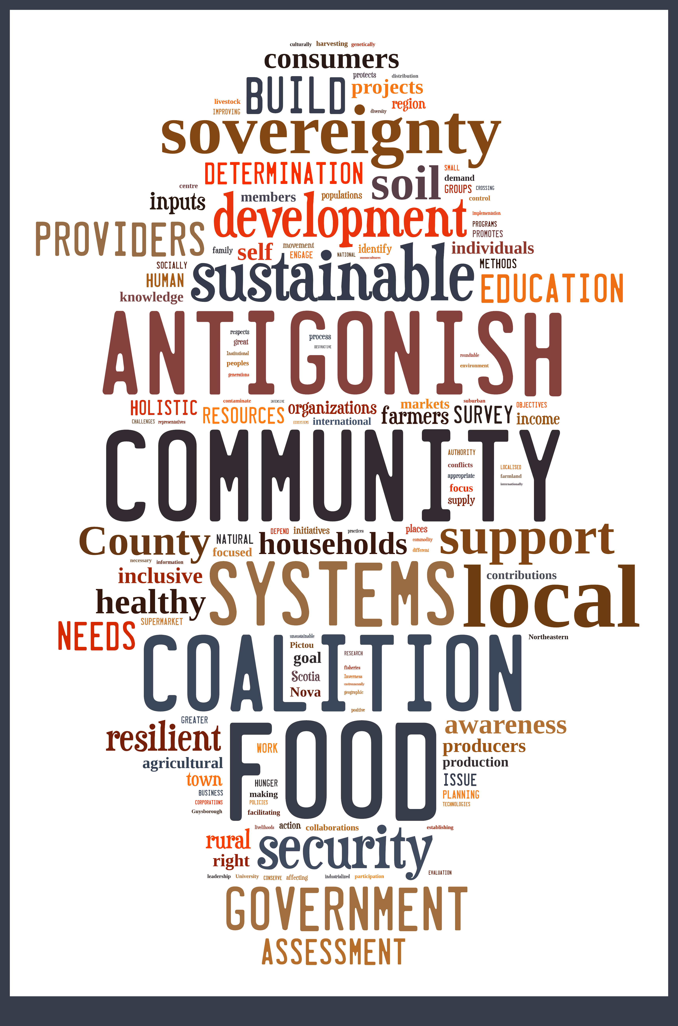

For more information on CURA’s ACT of CFS please visit <http://www.foodsecurityresearchcentre.ca/ actforcfs>
For more information or further reading on sustainable community movements http://www.transitionnetwork.org/, http://www.cittaslow.org/, http://www.naturalstep.org/, http://www.forumforthefuture.org/project/framework-sustainable-economy/overview
See appendix five for full table of “Vegetable Self-Reliance”
See appendix six for full table of “Fruit Self-Reliance”
See appendix seven for full table of “Livestock Self-Reliance”
The largest catches in terms of weight were scallops at 20.1%, herring at 19.8%, lobster at 12.9%, and marine plants at 9.2%. In term of value, lobster topped the list at 40.1% ($195 million), scallops at 15.5%, snow crab at 13.9% and shrimp at 7.6%. Aggregated, shellfish generates 78% of the commercial fish landings in 2010 (NSDFA, 2010).
Breamore Co-op Food Market (Antigonish) closed its doors this past September (2012).
For more information and to see schematic design for new Antigonish farmers market, see < http://www. antigonishrda.ns.ca/news/article/schematic-design-for-new-farmers-market-building-unveiled/>
For more information on the report for a mobiles farmers market please see Go Local Enterprises (2011, March 30), Consulting Report: Mobile Farmer’s Market
This is the percentage of income producers generate off fruit and or vegetable production
V
4% require between 2-5 million and another 4% require between 4-5 million. Question corresponds with question in the previous section.

