The Nooksack Salmon Enhancement Association

A model salmon restoration project

Salmon get helping hand from volunteer group

Calvin Bratt
Lynden Tribune editor
March 20, 2002

With NSEA leading the way, persistence is paying off in the effort to restore salmon in Whatcom County.
Salmon are making a comeback in the Nooksack River system, but no one is proclaiming victory just yet.
By the looks of a work party along Fishtrap Creek in Lynden last Saturday morning, the Nooksack Salmon Enhancement Association is still waging a full-scale war to restore native salmon runs to their natural habitat.
At Heritage Park near the East Badger Road, some two dozen volunteers were braving a sharp Arctic wind to plant and mulch 300 tree saplings and to encircle them with protective plastic against damaging rodents. Lively talk, warm clothing and hot food helped bolster each person for the task at hand.

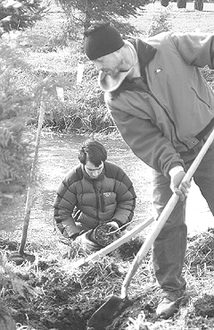
Lynden Tribune/TIMOTHY NEWCOMB

Dave Timmer of Bellingham, front, and Tom Chance of Bellingham plant trees along Fishtrap Creek just south of Badger Road during a work party on Saturday morning.

Weeks earlier, workers cut down blackberry bushes that had overgrown the Fishtrap banks. Still ahead, crews of the Washington Conservation Corps will add wire cages and fences to keep beavers from cutting down young trees prematurely.
It's all part of "recreating a functioning riparian area," said Frank Corey, a WCC crew leader who is full-time on stream restoration detail.
They're seeing results.
Erin Harwood, volunteer coordinator with NSEA, said that a count of returning salmon on Fishtrap Creek last fall yielded encouraging numbers. At three separate spots from Lynden to the Canadian border, counters found 245 chinook salmon and 35 redds (spawning areas), 52 cohos and five redds, and 16 chums and one redd.
An even more striking story of salmon resurgence is shaping up on the North Fork of the Nooksack River. There in 1990, just 10 native-run spring chinook salmon were counted, a low point after years of gradual decline. Last fall, however, the count of returning salmon was an amazing 2,185.

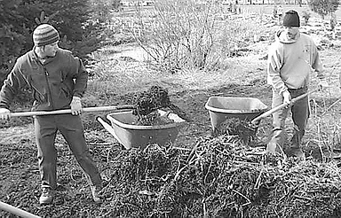
Lynden Tribune/CALVIN BRATT

Tom Desgroseillier and Dave Timmer, both of Bellingham, scoop their wheelbarrows full of the rough mulch that will be placed around newly planted trees.

The annual meeting of the Nooksack Salmon Enhancement Association -- usually just referred to by the handy acronym N-Sea -- in Bellingham last week was an occasion both to celebrate the past year's accomplishments and to rally the troops for projects still be done.
Over 12.5 miles of stream habitat restoration work was done in Whatcom County in 2001, reported Wendy Scherrer, NSEA executive director.
It takes a partnership of staff, volunteers, businesses, land owners, tribes and governments to make it all happen, Scherrer said. NSEA is based at 2445 E. Bakerview Road in Bellingham.
At the meeting at The Majestic on North Forest, County Council member Dan McShane spoke of quality of life issues, Lummi storyteller Pauline Hillaire told a tribal legend of Salmon Woman, and a pair of Bellingham law firms presented a donation of $60,000 to NSEA.
Since 1990, through matching grants and the volunteer base, NSEA has been working to restore self-sustaining salmon runs in the county through habitat restoration, scientific monitoring, community education and salmon stock production.
"Volunteers are the foundation of our organization. We would have a difficult time accomplishing all that we do without the help of volunteers," Harwood said.
In one piece of the multi-faceted effort, acclimation ponds on three creeks -- Kidney, Deadhorse and Excelsior -- have helped to rebuild the North Fork native spring chinook run, with cooperation from the U.S. Forest Service and the Washington State Department of Fish and Wildlife.
At key seasonal times, NSEA people keep a 24-hour watch at the ponds to feed young fish, clean intake and outtake screens and monitor water temperature of the ponds. Juvenile salmon implanted in the acclimation ponds will return to the streams to spawn, restoring the natural cycle.
Saar Creek east of Nooksack has been strengthened as a "highly productive salmon habitat" through slope stabilization, erosion control and close monitoring of returning fish, according to displays at the annual meeting. Partners include the Whatcom County Public Works and Sheriff's Departments.

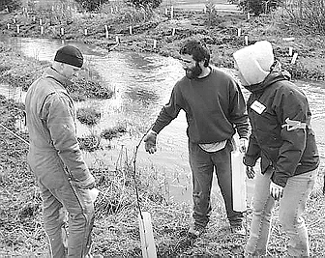
Lynden Tribune/CALVIN BRATT

Jeremy Brown, James Kardouni and Anne Brenchley evaluate the work being done Saturday morning in Lynden's Heritage Park along Fishtrap Creek.

Other sites of NSEA work are Deer Creek near Ferndale, Ten Mile Creek in the central county, Bertrand Creek west of Lynden, Hutchinson Creek in the Acme area, and Whatcom and Squalicum creeks in Bellingham.
Partners also include schools, through the NSEA's Students for Salmon program for grade schoolers and independent high school salmon enhancement projects. Senior biology techer Harlan Kredit at Lynden Christian High School said he has used NSEA staffers often for training and supplies.
"They're a great organization and we've worked with them a lot," Kredit said.
Students from the two Lynden high schools were scheduled to do some work on the Heritage Park project yet this month, if weather cooperated.
In all, some 2,500 trees will be planted on the Lynden city-owned park land this spring, Corey said.
Early spring is the season to do these types of streambank projects, so volunteers just need to persevere no matter what the weather, he said.
More work parties mean more volunteers needed
Volunteers can help the Nooksack Salmon Enhancement Association plant native vegetation along Fishtrap Creek this Saturday, March 23.
The work party will be from 9 a.m. to 12 noon at Heritage Park, along East Badger Road just west of Vinup Road.
The riparian restoration project is a cooperative one of Lynden City Parks, the Washington Conservation Corps and NSEA.
Contact Erin Harwood, NSEA volunteer coordinator, at 715-0283 or e-mail to erin@n-sea.org.

©Orca Network
Please contact Orca Network to inquire
about educational use of any materials on this site.

