GMO JEOPARDY GAME: Everything about GM Foods in short Q + A Form

This game was created by Julie Emerson, who is a long time participant in GEFreeBC and a member of the Canadian Biotech Action Network (CBAN). It was first circulated on the CBAN listserv in February 2009.

“I’m happy to offer you this educational project about GM food that I’ve just done. It’s suitable for adults at the events many of us hold and for university students. It’s a binder of Everything about GM Foods in short Q + A Form, which can also be used for the GMO JEOPARDY GAME. It was inspired by a GE Jeopardy game produced by SFU students under GE Free BC supervision last year. A binder of these 25 pages can be used as a reference immediately for anyone staffing a table at a Seedy Saturday, Farmers’ Market, or GMO film table, doing research, etc. Below is a photo of the Game (The (81/2 x 11” landscape) pages are folded in half over card, so the questions & answers are on opposite sides; cards are fanned out in 5 envelopes to choose from; prizes are non-GMO organic popcorn) All the Q + A are on the attached Word document.

There are 5 Categories: gardening & farming, health effects, the environment, food shopping, biology & society with 5 questions each, a/b/c/d choices with detailed answers (*more than 1 answer may be correct) Answers are from my up-to-the-minute research; you can update answers in future, if you want.)
cheer,

Julie Emerson”

[Note that a YouTube video of the famous GE FreeBC Popcorn Packet can be found on Julie’s website: http://www.julieemerson.com/index.htm]

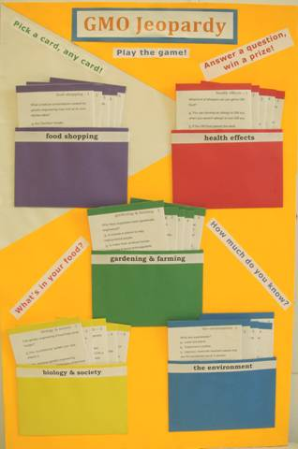

GMO JEOPARDY GAME: Everything about GM Foods in short Q + A Form
5 Categories, 5 questions each, a/b/c/d choices with detailed answers (*more than 1 answer may be correct)

gardening & farming
1. Why have vegetables been genetically engineered?
2. How do you know if your garden seeds have been genetically modified?
3. What are Terminator seeds?
4. How has genetic engineering improved farm crops?
5. What’s the difference between traditional plant breeding and genetic engineering?

health effects
1. What kind of allergies can you get to genetically modified food?
2. Which invisible health hazard created by the spread of GM food most worries physicians?
3. What kind of testing of the safety of GM food has been done?
4. What happens when food is genetically engineered to produce pharmaceutical drugs?
5. What are the effects of feeding GM food to children?

the environment
1. What are superweeds?
2. Where in the world are there GE-Free Zones?
3. What are the effects of genetic engineering on animals and insects?
4. How will production of GM crops for biofuel affect the environment?
5. What is biopiracy?

food shopping
1. What unnatural combinations created by GE may end up on your kitchen table?
2. Of the 70% of supermarket products that have been GE, what are the 3 staple foods?
3. You’re vegetarian or vegan - what could be more natural?
4. What sweeteners that you use regularly may be GE?
5. How can you avoid genetically modified food?

biology & society
1. Can genetic engineering of food help world hunger?
2. What’s the connection between Canadian and American governments and the agribusiness giant Monsanto?
3. What kind of scientific procedure is genetic engineering?
4. How has the use of GM seeds affected farmers in society?
5. Who owns the food supply?

