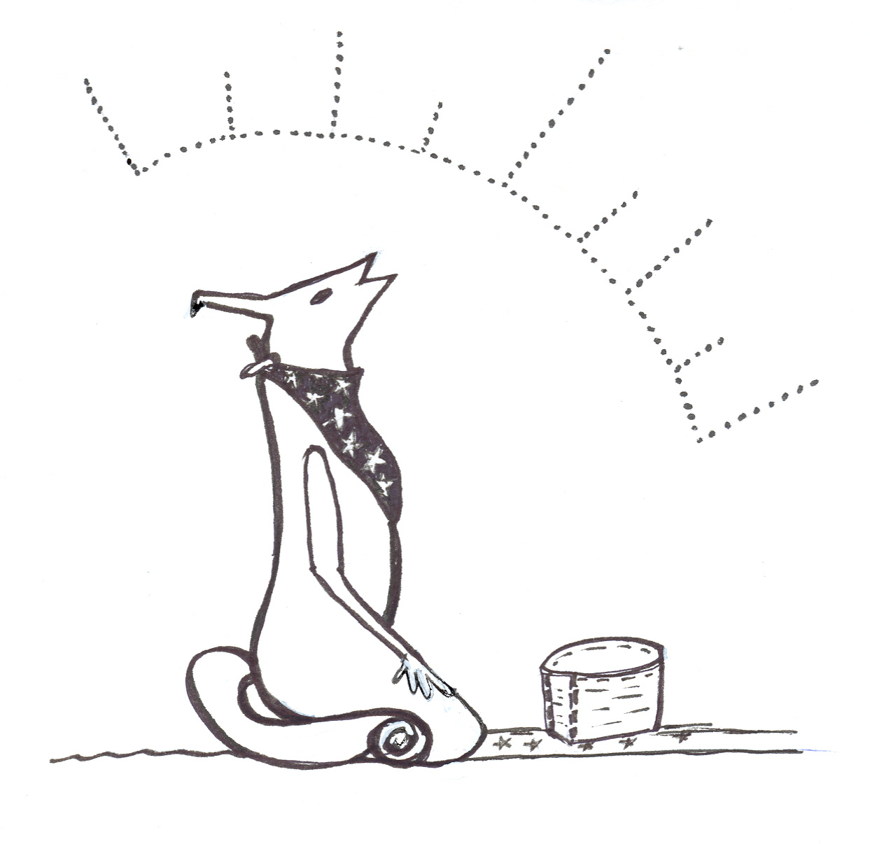

2nd Annual Interior of B.C.
Indigenous Food Sovereignty Conference

Ckultn
“How we grew up”

Final Report

Prepared for: Lakes Secwepemc Sustainable Community Building Society and the Community Food Action Initiative – Interior Health
Prepared by: Dawn Morrison, Conference Coordinator
dawnm@cablelan.net

October, 2007

TABLE OF CONTENTS

1. Acknowledgements......................................................................................................... 3
2. Introduction: Indigenous Food Sovereignty – The Concept .................................................................. 4
3. Who are we? Indigenous Peoples in the Southern Plateau of B.C........................................................ 5
4. The Conference – Participants.......................................................................................................................... 6
5. What happened at the Conference? .............................................................................................................. 6
Objectives..................................................................................................................................................... 7
Agenda........................................................................................................................................................... 7
6. What the outcomes were? Action Plans........................................................................................................ 8
Working Group #1 – Food, Land and Culture.................................................................................... 8
Working Group #2 – Health and Nutritional Values of Indigenous Foods........................... 10
Working Group #3 – Generations and Youth Perspectives. . ................................................... 11
Working Group #4 – Indigenous Food Economies...................................................................... 12
Working Group #5 – Strategies to Protect, Conserve and Restore IFS................................ 12
7. Long term plans for sustaining the outcomes.......................................................................................... 14
8. Lessons or experiences we would like to share........................................................................................ 14

2
Acknowledgements
Thank you to the following donors, sponsors and funding agencies who made the 2nd Annual Interior of B.C. Indigenous Food Sovereignty Conference possible through their generous financial contributions.

Funding Programs
Community Action for Health Initiative – South Okanagan
Community Food Action Initiative – Interior Health

Donations (Cash and fundraising items)
Askews Foods, Salmon Arm, B.C.
B.C Aboriginal Diabetes Conference
Bistro 333, Chase, B.C.
Chase Tattoo, Chase, B.C.
En'owkin Centre
Kamloops Food Bank
Nature's Fare Natural Foods, Kamloops, B.C.
Nutter's Natural Foods, Kamloops, B.C.
Pro-Organics, Vancouver, B.C.
Safety Mart, Chase, B.C.
Sam Saul, Simpcw, Barriere, B.C.
Shanghai Restaurant, Kamloops, B.C.
Skahish Esso
Spallumcheen Indian Band
Stellar Seeds, Sorrento, B.C.
The Grind Coffee House, Kamloops, B.C.
The Laughing Pumpkin Vintage Fashion, Chase, B.C.
Tribal, Chase, B.C.
Willows Natural Foods, Chase, B.C.
Zak's Coffee House, Kamloops, B.C.
All individuals who purchased tickets to the Wild Foods Feast Fundraising Dinner in August 2007

3
^{2nd} Annual
Interior of B.C.
Indigenous Food
Sovereignty Conference

October 5, 6 & 7, 2007

Neskonlith Indian Reserve #2
Chase Community Hall, Chase, B.C.

“Ckultn – How we grew up”

Background Information: Indigenous food sovereignty - the concept

The food sovereignty approach is the newest and most innovative approach to addressing the complex issues impacting our traditional land and food systems. It has grown out of a social network of Non Government Organizations (NGO's), Civil Society Organization's (CSO's), social movements and many conferences, meetings and discussions that have taken place both within our region and around the world. The concept was developed by a global farmer's movement Via Campesina and was launched to the general public at the World Food Summit in 1996. While there is no universal definition of food sovereignty the most common one referred to in the international community is as follows.

“Food Sovereignty is the Right of peoples, communities, and countries to define their own agricultural, labour, fishing, food and land policies, which are ecologically, socially, economi-cally and culturally appropriate to their unique circumstances. It includes the true right to food and to produce food, which means that all people have the right to safe, nutritious and culturally appropriate food and to food producing resources and the ability to sustain themselves and their societies.”

The food sovereignty approach provides a framework to explore, analyze and describe the main elements of protecting, conserving and restoring Indigenous food systems as it relates to the our unique cultures and circumstances in the interior of B.C. Based on discussions that took place at the 1st and 2nd Annual Interior of B.C. Indigenous Food Sovereignty Conferences, four main principles of indigenous food sovereignty (IFS) have been described.

- Sacredness – Food is a gift from the Creator; we have a sacred responsibility to nurture healthy, interdependent relationships with the land, plants and animals that provide us with our food, medicines and technologies.
- Self-determination-The ability to respond to our own needs for safe, healthy, culturally adapted indigenous foods - the ability to make decisions over the amount and quality of food we hunt, fish, gather, grow and eat. The ability to be free from dependence on grocery stores or corporately controlled food production and distribution in market economies.
- Participatory - An action that is ultimately based on the day to day practice of
maintaining our traditional food harvesting strategies and practices for the benefit of present and future generations. A cultural strategy that must be practised at all of the individual, family and community levels.
- Policy - A strategy for influencing provincial, national and international policies that are negatively impacting traditional land and food systems.

Who are we? - Indigenous Peoples in the Southern Plateau of B.C.
We are the original peoples of the southern portion of the interior plateau of B.C. We have developed distinct cultures and ways of life based on nurturing healthy interdependent relationships with the land, plants and animals that provide us with our food, medicines and technologies. We share similar environments and cultures and therefore apply similar traditional food harvesting strategies such as: hunting, fishing, gathering and cultivating culturally important plants and animal species in the diverse ecosystems throughout the region. Throughout the history of colonization, many traditional harvesters have witnessed the rapid erosion of our traditional land and food systems. Modern pressures of industrialization, globalization, urbanization, privatization and forced assimilation into mainstream society have resulted in the declining health and integrity of our cultures, ecosystems, social structures and knowledge systems which are integral to our ability to respond to our own needs for adequate amounts of healthy traditional foods. To maintain the remaining fragments of our traditional land and food systems in the region, it is necessary to devote concentrated time and energy on: 1) increasing awareness of the ways in which present and future generations can work to restore harmony in our relationships with the land, plants, animals, and one another, and 2) influencing neo-liberal policies and corporate agendas that have severely degraded the health, access and abundance of culturally important foods in our traditional territories.
5

The Conference – Participants

Building on the success of the 1st Annual Interior of B.C. Indigenous Food Sovereignty Conference (IFSC 2006), the Lakes Secwepemc Sustainable Community Building Society agreed to take the leading role in hosting the 2nd Annual Interior of B.C. Indigenous Food Sovereignty Conference (IFSC 2007) which took place in Chase, B.C. on October 5, 6 & 7, 2007.

The conference brought together 42 participants from the Syilx, Secwepemc, Gitsxan, Nuxalk, Haida, Metis/Cree and Peru (Aymara) nations who either 1) who currently reside in the southern plateau region, or 2) are actively involved involved with Indigenous food related action, or 3). are interested in learning more about the issues.

The conference brought together participants from the following communities:
- Traditional harvesters (hunters, fishers and gatherers)
- Organic gardeners
- Cultural teachers
- Youth and Elders
- Community workers
- Political advocates

While the number of participants was lower than anticipated, those in attendance demonstrated a deep level of commitment and understanding of the social, cultural, environmental and political transformation that is required in order to protect, conserve and restore traditional land and food systems in the region.

What happened at the Conference?

Based on an overview of the Final Report from the IFSC 2006 as well as information provided by keynote speakers, participants came together to analyse, inquire, discuss, and identify practical ways to implement action items identified in IFSC 2006. (For more information on action items view the Final Report for the IFSC 2006 on the B.C. Food Systems Network website address: www.fooddemocracy.org/links.php ). Working groups and roundtable discussions were facilitated in a culturally relevant - integrated and flexible manner. Each working group followed one of the five central themes in a discussion process that encouraged learning, transformation and healing.

6

The main objectives of the conference were to:

- Promote the intergenerational transmission of Indigenous food related knowledge especially between children, youth and Elders.
- Provide opportunities to observe and experience practical hands on activities related to harvesting, preparing, and preserving Indigenous foods. I.e. Pit cooking workshop
- Provide opportunities to enhance or establish traditional food exchange or trade networks within the interior region
- Give an expression to the real struggles of Indigenous peoples upholding our inherent responsibility to nurture and take care of our relationships to the plants and animals within traditional land and food systems.
- Presenting our proposals from the perspective of food sovereignty on issues related to agrarian, forestry, fisheries, rangeland, water reform and rural and community self - development.

Agenda
Day One
Keynote Presentations
1. Cultural Affirmation, Decolonization and Self Determination by Dr. Tirso, Gonzales (Peru Aymara)
2. Structures and Processes for Upholding our Sacred Responsibilities to Protect, Conserve and Restore Indigenous Food Systems by Mas Gak, Don Ryan (Gitsxan)
3. Overview of IFSC 2006. Conference Coordinator, Dawn Morrison, Secwepemc

Practical Workshop and Poster Sessions
1. Pitcooking with Nicole Manuel (Workshop)
2. Traditional Medicines with Rona Tomma (Poster Session)
3. Lakes Secwepemc Sustainable Community Building Society - Traditional Harvesting and Community Gardens (Poster Session)

Plenary Presentation and Discussion
Food, Land and Culture: Presenter Rob Matthews, Chief Atahm Shuswap Immersion School, Adams Lake Indian Reserve

6

Working Groups: Action Planning

1. Health and Nutritional Values of Indigenous Foods: Facilitator Joyce Manuel, Secwepemc
2. Generations and Youth Perspectives in the Struggle to Protect, Conserve and Restore Indigenous Food Systems: Facilitator: Francis Billy, St'at'imc – Youth Worker
3. Indigenous Food Economies: Facilitator: Tara Willard, Secwepemc, Around the Kitchen Table Project Coordinator
4. Strategies to Protect, Conserve and Restore Indigenous Food Systems: Facilitator Dawn Morrison, Secwepemc, IFSC 2006 & 2007 Coordinator

Day Two

1. Community Activity Reports - Traditional Harvesting of Scwicw (Glacier Lily) Research report by Jacqueline Jones
2. Roundtable Discussions and Working Groups continued...

What the outcomes were?
Following the theme of “Ckultn”, which is a Secwepemc term that translates to “how we grew up”, the conference supported and facilitated the development of regional networks and participatory learning events that promote cultural strategies and practices that are integral to passing on traditional food related knowledge through the generations. The conference enabled participants to explore ways in which to adapt our individual, family, community and regional food networks and activities in a way that applies traditional teachings, and increases our ability to make healthy decisions about the ways we respond to our needs for healthy culturally adapted food through hunting, fishing, gardening or gathering.
Working Group #1 – Food, Land and Culture
Food
- Avoid buying meat from the grocery store
- Canning workshops
- Community fishing and hunting camps (informal) for young peoples – need equipment, tools and knowledge.
- Teach children how to skin and butcher meat
- Barter and trade – eg. bullets and gas in exchange for meat (deer, moose, elk etc...)
- Cultivate the land – dig scwicw and other important root vegetables.
- Study ethnobiology - Learn “backstage knowledge” of how to harvest, prepare and preserve traditional foods.
- Take and show pics.
7

Land
- Observe climate change.
- Get grounded and in tune with lunar cycle.
- Ceremonies sharpen senses and register signals of what is coming, learn to recognize and observe indicators.
- Need to connect the language to the land and our traditional way of life - land title lies in our language.

Cultural Affirmation, Decolonization and Self-determination
- Learn to reflect and go back to looking after ourselves.
- The issue of food sovereignty is about world views and community participation.
- Challenge western culture's notion of “development” and concept of time.
- Culture is unique and requires continuous expression, do not abandon.
- Every cultural concept should be scrutinized – do they fit within our world view?
- Practice Spirituality - make time for prayers, thanks you's, and giving back.
- Live in the present - tomorrow hasn't been decided, the past has already been decided.
- Make the time – be aware of what is competing for your time, set aside time for traditional food harvesting and cultural activities and say no to everything else.
- Don't need to wait for the band office to learn. It is “our” job – stop allowing other institutions to take over responsibilities.
- Actual doing – all in the participation, there is no right way or wrong way.
- Build upon model projects.
- Ask the questions: What is available and how do I get there? Who is on your team? Who has the skills and knowledge that you can call upon? Practice humility – Can you show me?

Language Revitalization
- Native languages hold more wisdom than the English language – one word can give you a deeper meaning than a few words in English.
- Bring out latent language speakers through both formal and informal language conversations and lessons – fluency is related to life experience.
- Recognize that we are in a constant process of creation of dialects and change. Commitment to being disciplined in learning language and culture most important.
- Don't get too caught up in limits and rules imposed by linguists, orthographists and dialects – that way our own people can get back into the circle and become functional enough to be fluent in our own life experience.

8

Social
- Avoid “Elderism” - be more inclusive of all generations.
- Avoid separation by gender.
- Stop being critical of others in our own nations. Drop differences and support each other.
- Encouragement - organize social networking, teaching, sharing and togetherness, stop working in isolation.
- Sharing knowledge and access is more important than what we keep in our pockets.
- Getting food is about relationship building – learn how to connect again.
- Support each other and build families.
- Family gathering – make sure everyone is looked after, help one another. Take the kids out to harvest and heal.
“ I will help you look after yourself. I will help you look after others”.
Conference participant
- Make a fun time of it.

Working Group #2 – Health and Nutritional Values of Indigenous Foods

Physical health
Get regular physical exercise while hunting, fishing and harvesting traditional foods.
Encourage people at your workplace to serve traditional foods and avoid sugar, salt, ketchup,
vinegar, hot dogs, donuts, coffee mate and foods high in trans fatty acids.
Promote and encourage breastfeeding as long as possible.
Mental health
Become knowledgeable of the consequences and risks involved with making unhealthy food choices.
Learn your choices and make a commitment to healthy living through a holistic approach.
Alcoholism vs. “alcoholwasm' – believe that you can overcome alcoholism and do not have to be labelled that your whole life.
Emotional health
Learn about the ways that addictions such as: alcoholism, gambling and drug abuse affect your eating habits.
Heal past emotional hurts to avoid unhealthy coping strategies of overeating or under-eating.
Build healthy self-esteem by accomplishing and building on small tasks.
Recognize your ability to respond to your own needs for healthy foods - self esteem is important, help yourself and care for yourself.
Overcome fears of raising children on the land.
9

Spiritual health
Pay attention to signs in nature.
Learn songs and dances and participate in ceremonies. I.e. smudging, sweats, fasts, sun dance, winter dance, ghost dance, receiving of name, becoming of age.
Learn about the lunar cycle, watch the stars.

Working Group #3 – Generations and Youth Perspectives in the Struggle to Protect, Conserve and Restore Indigenous Food Systems
“Use it or lose it”. Youth participant

- Be concerned about what future generations will think about us if we don't take care to pass along traditional teachings of food, land and culture.
- Ask the question: how can I reach the young people? The younger they are exposed to the practice of traditional harvesting, the better.
- Reconnect youth with the land through activities such as hunting, camping etc...
- Organize cultural, science and traditional camps to teach generations about areas of history and place names – rally the whole community together.
- Learn and teach oral history associated with harvesting sites and areas of concern.
- Share information about sensitive sites with community.
- Identify areas to restore and teach youth.
- Teach and learn whole associations of plants, shrubs and animals pertaining to specific harvesting areas - learn the ecosystem and the benefits of protection.
- Ask youth the question: how do we deal with lack of access in our own territory?
- Teach and learn protocols for harvesting and outside interest user groups.
- Bring back cultural beliefs of providing for families.
- Commit time to harvest and care for land, plants, animals and one another.
- Bring back ceremonies, rituals and rites of passage – first kill, first fish, berrypicking and harvesting etc...

10
Working Group #4 – Indigenous Food Economies
Live to work and work to live - “The land is our job”.
Conference participant

- Provide financial support for people to get back out on the land.
- Create an alternative economy through barter and trade with Indigenous peoples from other nations.
- Organize a co-op and place a high value on what we are doing.
- Incorporate into a non-profit society for the purpose of developing a co-op.
- Set up communication networks – utilize existing ones and develop new ones.
- Seasonal or bi-monthly magazine.
- Develop lists of artists, food co-ops, farms, harvesting in specific areas. I.e. directory, website, phone list.
- Do market research – network with artisans and craftspeople.
- Research historic trading networks.
- Re-establish grease trails.
- Intermarriage – establish trade relationships through marriage.
- Trade food in exchange for experience / work – ie. working on organic farm or work on traditional harvesting (hunting, fishing and gathering).
- Organize interior artisan barter fairs. Suggested locations: Green Lake, Secwepemc Museum and Heritage Park (SCES), Williams Lake, Okanagan.
- Get funding to do the work – fundraising, proposals, business loans.
- Analyse value system: how to price, value and regulate the traditional food and non-timber forest products.

Working Group #5 – Strategies for the Protection, Conservation and Restoration of Indigenous Food Systems.

- Promote the values of co-operation versus individualism – everyone get together to solve the problem.
- In situ - how to be related to each other through the “actual doing” and participation in the situation .
- Ex-situ – outside organizations, NGO'S, policy makers, researchers, agronomists etc... working within 4 walls outside of the situation.
- Eco-centric approach more balanced than mechanistic industrial approach.
10
- Tackle one issue at a time.
- Get out of desperation mode.
- Make a list of the things you need - spear, money, transportation, food, tents etc...
- Source the systems – use all the tools we can to make sure our culture stays together.
- When something is good assimilate, when something is bad reject it.
- Decide our destiny based on cultural diversity.
- Identify and map potentialities/assets (appreciative inquiry) instead of focusing on needs and poverty mentality.
- Apply a “wealth and abundance mentality”.
- Question the status quo.
- Advocate for hunting, fishing and gathering reserves and zones set aside specifically for indigenous food systems – areas where indigenous foods would be protected.
- Document land use/share with others (find some way to document) – eg. mapping, taking and showing pics.
- Re-enact the Confederated Traditional Okanagan Shuswap Nation Declaration.
- Get outside the boundaries created by the Department of Indian Affairs – break the bind of the reserve system.
- Re-establish traditional hunts around Valemont area.
- Mitigation of mining impacts – protect sources closest to communities (establish buffer zones).
- Not asking permission from the colonial government and the crown arises out of our relationship to the land.
- Challenge Ministries of Forests and Range, Agriculture and Lands, Energy and Mines, and Environment to recognize and incorporate Indigenous food and cultural values into policies and practices – make allowances for fish, animals, berries and traditional use in land use planning.
- Interact with governments following our own laws.
- Work with band councils - consultation cannot take place only within band councils.
- More organization needed to say no to what is being imposed.
- Bring houses together in a traditional form or institution that applies a diplomatic process of building consensus.
- Respect each others opinions with integrity, get the community together to figure out the best things.
- Takes a lot of time and patience to reach consensus.
- Families working together as a collective, rights are held in the collective.
- Get rid of lawns and yards.
- Prune Saskatoon's and other berries. Burn berry patches. - learn words of that activity in your language.
11
Long term plans for sustaining the outcomes
- Rotating host of conference from nation to nation.
- Share information on planning, coordination, hosting and follow up of conference with those who express an interest in hosting a conference in their nations, communities or regions. I.e. Nuxalk
- Work with the Interior of B.C. Indigenous Food Sovereignty Conference Planning Committee (IFSCPC) and the B.C. Food Systems Network - Working Group on Indigenous Food Sovereignty to map potentialities.
- Work with community organizations to adapt and apply the food sovereignty assessment tool developed by the First Nations Development Institute.
- Develop sustainable funding strategy that includes soliciting donations from sympathetic individuals, organizations and philanthropists.

Lessons or experiences we would like to share
- The issue of food sovereignty is fundamentally about world views, community participation, and social healing.
- Cross cultural challenges associated with contradicting world views, concepts of time, and approaches to healing and restoration are systemic barriers that make it difficult to evaluate the outcomes of the conference on a long term basis.
- Issues related to social healing and the intergenerational transmission of traditional food related knowledge, values, wisdom, strategies and practices are inseparable.
- Tribal social structures provide a framework for restoring social harmony where individuals, families and communities are encouraged to work together in their relationships to the food, land and one another.
- Restoration of cultural strategies and practices requires a balanced approach between a “process and product” orientation.
- Some of the most food insecure people are those that are striving on a day to day basis to overcome Post Traumatic Stress Disorder (PTSD) and related fear and anxiety of what the future holds.
- Working in a “day to day survival mode” poses challenges in the process of planning for the future and identifying specific actions, resources needed, and timelines.
- The format and methodology of meetings, conferences and planning processes must be culturally relevant, flexible and accommodate a balance between the flexible nature of the oral tradition and a respect for the time and energy that went into program planning – be willing to switch between a roundtable/plenary format and more focused discussions in working groups.
- Be willing to facilitate a process of identifying communication guidelines and formats of discussion that are acceptable to participants.
12

Information taken from the Food Sovereignty: towards democracy in localized food systems paper (Windfur and Jonsen, 2005). For more informaton visit the Nyeleni Forum for Food Sovereignty website address: http://www.nyeleni2007.org/spip.php?article88 4

