Note:

The following page comes from the Western Canada Wilderness Committee. http://www.wildernesscommittee.org/campaigns/wildlife/bc/reports/Vol27No05

It has been modified only to remove those features that are part of a web page but do not transpose correctly to a Word document. (web pages cannot be uploaded directly into Bits and Bytes).

Western Canada Wilderness Committee

People living in British Columbia know that we live in a special place. Our diverse geography which consists of 14 distinct climates, ranging from rainforests to pocket deserts, contributes to a quality of life that truly makes BC the best place on earth to live. This tremendous diversity also makes us the most species-rich province in all of Canada. Grizzly bears, wild salmon, eagles and killer whales are part of the ecological wealth for which BC is famous. Today, these natural treasures are just a few of the 1,300 endangered species in BC, a province with no endangered species legislation. Read on to find out how you can help to make sure British Columbia remains the best place on earth for us and our wildlife.
Bottom of Form

Why doesn't BC have Endangered Species Legislation?

Wilderness Committee Educational Report Vol.27 - No.05, Summer 2008
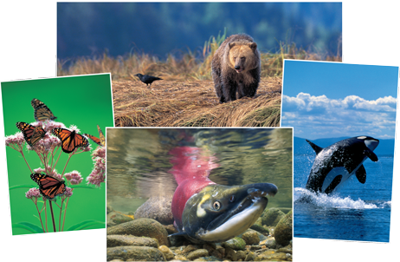Monarch butterflies, killer whales, grizzly bears, and many runs of salmon are just some of BC’s 1,300 species at risk. Monarch butterfly (Danaus plexippus) by Robert McCaw. Killer whale (Orcinus orca) by Thomas Kitchin/Fist Light. Grizzly bear (Ursus arctos horribilis) by John Marriott. Sockeye salmon (Oncorhynchus nerka) by Wayne Lynch.

There ought to be a Law
Did you know British Columbia has NO endangered species legislation?
By Gwen Barlee
Policy Director, Wilderness Committee
People living in British Columbia know that we live in a special place. Our diverse geography which consists of 14 distinct climates, ranging from rainforests to pocket deserts, contributes to a quality of life that truly makes BC the best place on earth to live. This tremendous diversity also makes us the most species-rich province in all of Canada. Grizzly bears, wild salmon, eagles and killer whales are part of the ecological wealth for which BC is famous. Whether watching a chickadee in our back yard, fishing for trout, or glimpsing a bald eagle flying overhead, our identity as British Columbians is shaped by our encounters with nature.
Growing up in the Okanagan Valley in the dry southern interior of British Columbia, my connection with nature was through wildlife watching. On the way to school I would count the di f ferent bird species. Brilliant mountain bluebirds, melodic meadowlarks, yellow-headed black birds, American goldfinches, cedar waxwings and tiny ruby-throated hummingbirds were just some of the birds I saw in the meadows, orchards and woods near my home. On weekends, wildlife viewing took on a new dimension. I would often come along with my dad as he drove through the backcountry. Stopping near Keremeos we would count the dozens of mountain goats perched high on the grey cliffs above Highway 99. Driving by Vaseux Lake near Okanagan Falls, we would pull over to catch a glimpse of the Rocky Mountain bighorn sheep that grazed near the old apple orchards.
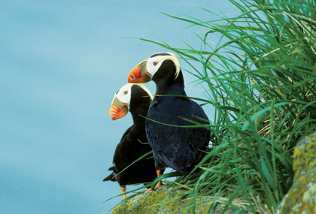Tufted puffins (Fratercula cirrhata) by Wayne Lynch.
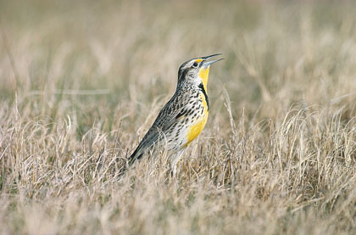Western Meadowlark (Sturnella neglecta) by Wayne Lankinen.
As a child I took delight in this web of life. The croaking of frogs in our backyard and the hum of crickets when dusk fell offered me an affirmation that all was right with the world.
However, I also took the meadowlark and the bighorn sheep for granted - part of the ecological fabric of a province that seemed to have endless natural treasures. Today, these natural treasures, Rocky Mountain Bighorn sheep and meadowlarks, are just two of the 1,300 endangered species in BC - a province with no endangered species legislation¹. From Peregrine falcons to monarch butterflies, endangered wildlife in BC are left to fend for themselves against toxic contamination, urban sprawl, logging, industrial development, invasive species and a provincial government that won’t stand up for species at risk.
British Columbia’s lack of endangered species legislation is particularly surprising given the province’s tremendous environmental wealth. BC is Canada’s most biologically rich province containing 66% of Canada’s butter fly species, 70% of its freshwater fish species, 76% of its bird species, 60% of its conifer species, 56% of its fern species, and 41% of it s orchids² . BC is also home to almost half of Canada’s grizzly bear population, and 250 species of birds - half of which breed nowhere else in Canada³.



Articles
- There ought to be a law
- What is an endangered species?
- The lay of the land in BC
- What a BC endangered species law should look like
- Be a part of the solution!
- Related Sites Info, Credits & Footnotes

